c

Prepared by:

September 8, 2025

2025 Conservation Potential Assessment

Inland Power & Light Company

# Table of Contents

Table of Contents i

List of Figures iii

List of Tables iv

Executive Summary 1

Overview 1

Results 2

Comparison to Previous Assessment 5

Conclusion 6

Introduction 7

Objectives 7

Background 7

Study Uncertainties 7

Report Organization 8

Methodology 9

High-level Methodology 9

Economic Inputs 9

Other Financial Assumptions 11

Measure Characterization 12

Customer Characteristics 12

Energy Efficiency Potential 12

Customer Characteristics 14

Residential 14

Commercial 15

Industrial 16

Utility Distribution System 17

Recent Conservation Achievement 18

Overall 18

Residential 18

Commercial 19

Industrial 19

Agricultural 20

Results 21

Achievable Conservation Potential 21

Cost-Effective Conservation Potential 22

Sensitivity Results 29

Summary 31

Compliance with State Requirements 31

References 32

Appendix I: Acronyms 33

Appendix II: Glossary 34

Appendix III: Compliance with State Requirements 35

Appendix IV: Avoided Costs 39

Avoided Energy Costs 39

Deferred Transmission and Distribution Capacity Costs 42

Deferred Generation Capacity Costs 43

Social Cost of Carbon 43

Renewable Portfolio Standard Compliance Costs 44

Risk Mitigation Credit 44

Northwest Power Act Credit 45

Summary 45

Appendix V: Measure List 47

Appendix VI: Cost-Effective Energy Efficiency Potential by End Use 52

Appendix VII: Ramp Rate Alignment Documentation 54

Ramp Rate Alignment Process 54

# List of Figures

Figure 1: Historic Targets and Achievements (MWh) 1

Figure 2: Cost-Effective Potential by Sector (MWh) 3

Figure 3: Annual Incremental Cost-Effective Energy Efficiency Potential (MWh) 4

Figure 4: Annual Cumulative Cost-Effective Energy Efficiency Potential (MWh) 5

Figure 5: Conservation Potential Assessment Methodology 9

Figure 6: Avoided Energy Costs 10

Figure 7: Types of Energy Efficiency Potential 13

Figure 8: Past Conservation Achievements by Sector (MWh) 18

Figure 9: Recent Residential Program Achievements by End Use (MWh) 19

Figure 10: Recent Commercial Program Achievements by End Use 19

Figure 11: Recent Industrial Program Achievements by End Use 20

Figure 12: Recent Agricultural Program Achievements by End Use 20

Figure 13: 20-Year Supply Curve 21

Figure 14: 20-Year Benefit-Cost Ratio Supply Curve 22

Figure 15: Annual Cost-Effective Potential by Sector 22

Figure 16: Annual Residential Potential by End Use 23

Figure 17: Residential Potential by End Use and Measure Category 24

Figure 18: Annual Commercial Potential by End Use 25

Figure 19: Commercial Potential by End Use and Measure Category 25

Figure 20: Annual Industrial Potential by End Use 26

Figure 21: Industrial Potential by End Use and Measure Category 26

Figure 22: Annual Distribution System Potential 27

Figure 23: Annual Agricultural Potential by End Use 27

Figure 24: Agricultural Potential by End Use and Measure Category 28

Figure 25: Benchmarking of On-Peak Prices 40

Figure 26: Benchmarking of Off-Peak Prices 40

Figure 27: On- and Off-Peak Price Forecast 41

Figure 28: Comparison of On-Peak Price Sensitivities 42

Figure 29: Comparison of Off-Peak Price Sensitivities 42

Figure 30: Council Marginal Emissions Rate Forecast 44

# List of Tables

Table 1: Cost-Effective Potential by Sector (MWh) 3

Table 2: Peak Demand Savings from Cost-Effective Energy Efficiency Potential by Sector (MW) 4

Table 3: Comparison of 2023 and 2025 CPA Results (MWh) 5

Table 4: Service Territory Characteristics 14

Table 5: Residential Existing Home Characteristics 14

Table 6: Residential New Home Characteristics 15

Table 7: Commercial Floor Area by Segment 16

Table 8: Industrial Sector Sales by Segment 17

Table 9: Utility Distribution System Efficiency Assumptions 17

Table 10: Avoided Cost Assumptions by Sensitivity 29

Table 11: Cost Effective Potential (MWh) by Avoided Cost Sensitivity 30

Table 12: CPA Compliance 35

Table 13: Energy Efficiency Avoided Cost Assumptions by Sensitivity 45

Table 14: Residential End Uses and Measures 48

Table 15: Commercial End Uses and Measures 49

Table 16: Industrial End Uses and Measures 50

Table 17: Utility Distribution End Uses and Measures 50

Table 18: Agricultural End Uses and Measures 51

Table 19: Cost-Effective Residential Potential by End Use (MWh) 52

Table 20: Cost-Effective Commercial Potential by End Use (MWh) 52

Table 21: Cost-Effective Industrial Potential by End Use (MWh) 53

Table 22: Cost-Effective Utility Distribution Efficiency by End Use (MWh) 53

Table 23: Cost-Effective Agricultural Potential by End Use (MWh) 53

Table 24: Alignment of Residential Program History and Potential by Measure Category (MWh) 55

Table 25: Alignment of Residential Program History and Potential by End Use (MWh) 57

Table 26: Alignment of Commercial Program History and Potential by End Use (MWh) 58

Table 27: Alignment of Industrial Program History and Potential by End Use (MWh) 58

Table 28: Alignment of Distribution System Program History and Potential by End Use (MWh) 59

# Executive Summary

## Overview

This report describes the methodology and results of a conservation potential assessment (CPA) conducted by Lighthouse Energy Consulting and Nauvoo Solutions (the project team) for Inland Power & Light Company (Inland Power). The CPA estimated the cost-effective energy savings potential for Inland Power’s Washington service area over the period of 2026 to 2045. This report describes the results of the full 20-year period, with additional detail on the 2- and 10-year periods that are the focus of Washington’s Energy Independence Act (EIA) and the 4-year interim compliance period per the state’s Clean Energy Transformation Act (CETA).

Inland Power provides electricity service to over 44,000 customers in eastern Washington. Inland Power also provides electric service to a portion of Idaho that is not included in this CPA. Washington’s EIA requires that utilities with more than 25,000 customers identify and acquire all cost-effective energy efficiency resources and meet targets set every two years through a CPA. A summary of Inland Power’s program achievements since 2012 is shown in Figure 1, based on EIA compliance data reported to Washington’s Department of Commerce.

Figure : Historic Targets and Achievements (MWh)

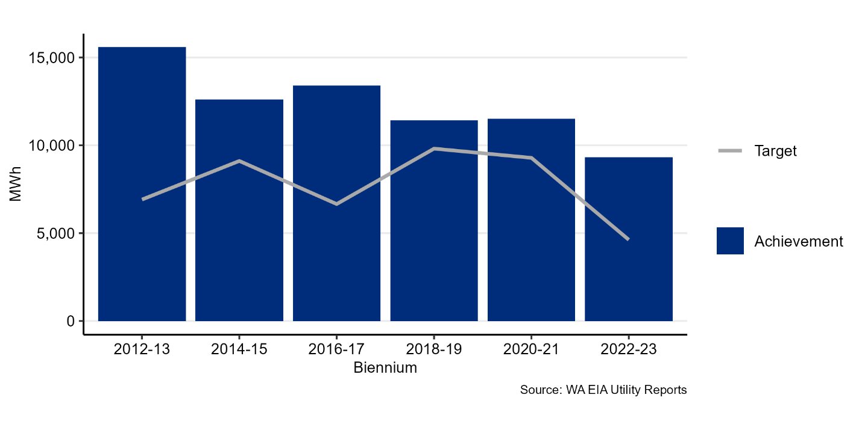

The EIA specifies the requirements for setting conservation targets in RCW 19.285.040 and WAC 194-37-070 Section (5), parts (a) through (d). The methodology used in this assessment complies with these requirements and is consistent with the methodology used by the Northwest Power and Conservation Council (Council) in the 2021 Power Plan. Appendix III details the requirements of the EIA and how this assessment fulfills those requirements. Washington’s CETA includes an additional requirement for CPAs; namely, that the assessment of cost-effectiveness use specific values for the social cost of carbon.

This CPA used much of the 2021 Power Plan materials, with customizations to make the results specific to Inland Power’s service territory and customers. Notable changes in this CPA relative to Inland Power’s previous assessment include the following:

* Energy Efficiency Measures
  + Measure savings, costs, and other characteristics were updated based on new information from the Regional Technical Forum (RTF). Multiple measures were updated across the assessment, generally resulting in decreases in the cost-effective potential.
* Avoided Costs
  + The assessment incorporated an updated market prices forecast that is significantly lower than what was used in the 2023 CPA.
* Customer Characteristics
  + Residential equipment saturations were updated with 2022 Northwest Energy Efficiency Alliance (NEEA) Residential Building Stock Assessment (RBSA) data when 2020 Inland Power survey data was unavailable. This update had minimal impact on the overall potential.
  + Customer counts and loads were updated using publicly available data and Inland Power provided nonresidential account sales for 2024. Residential and commercial sales and customer forecasts were fairly consistent between the two studies, while the industrial sector sales increased relative to the 2023 CPA.
* Program Impacts
  + Inland Power’s recent conservation program achievements were incorporated to account for what was already accomplished and inform near-term potential.

## Results

Figure 2 and Table 1 show the cost-effective energy efficiency potential by sector over 2-, 4-, 10-, and 20-year periods. Over the 20-year planning period, Inland Power has nearly 190,000 MWh of cost-effective conservation available, which is approximately 10% of its projected 2045 load. The EIA focuses on the 2- and 10-year potential, which are 2,741 MWh and 59,313 MWh, respectively. In the 4-year period covered by Inland Power’s 2025 Clean Energy Implementation Plan (CEIP), there are 8,799 MWh of cost-effective conservation potential available.

Figure : Cost-Effective Potential by Sector (MWh)

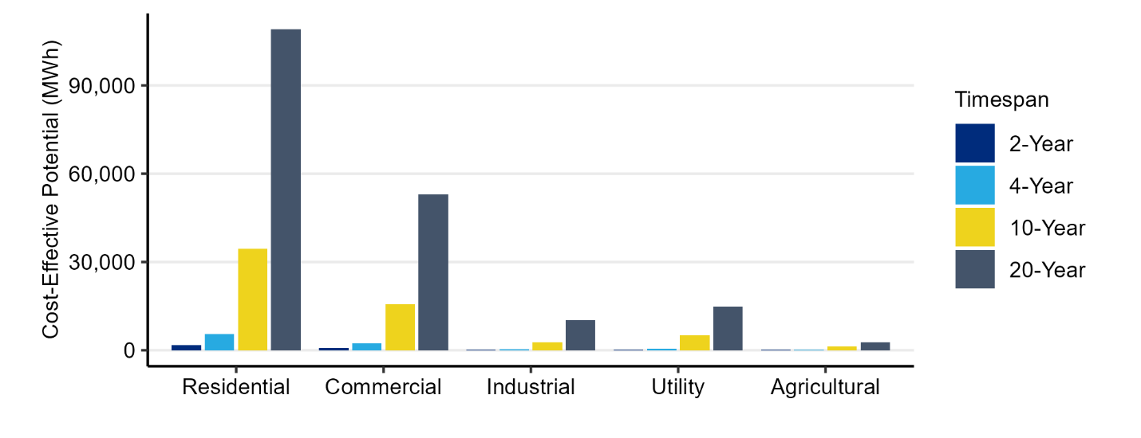

Table : Cost-Effective Potential by Sector (MWh)

|  |  |  |  |  |
| --- | --- | --- | --- | --- |
| **Sector** | **2-Year** | **4-Year** | **10-Year** | **20-Year** |
| Residential | 1,779 | 5,584 | 34,462 | 109,057 |
| Commercial | 719 | 2,285 | 15,667 | 52,961 |
| Industrial | 64 | 250 | 2,763 | 10,258 |
| Utility | 115 | 471 | 5,063 | 14,907 |
| Agricultural | 64 | 209 | 1,358 | 2,778 |
| **Total** | **2,741** | **8,799** | **59,313** | **189,961** |

*Note: In this and all subsequent tables, totals may not match due to rounding.*

The distribution of cost-effective potential across sectors is consistent over the study period with the residential sector offering the greatest proportion of potential. In the first two years, the residential sector makes up 65% of the cost-effective potential, followed by the commercial sector (26%), utility (4%), industrial (2%) and agricultural (2%).

This assessment does not specify how the energy efficiency potential will be achieved. Possible mechanisms include Inland Power’s own energy efficiency programs, market transformation driven by the NEEA, state building codes, and state or federal product standards. Often, the savings associated with a measure will be achieved through several of these mechanisms over the course of its technological maturity. For example, heat pump water heaters started as one of NEEA’s market transformation initiatives. They subsequently became a regular offering in utility programs across the Northwest and have recently become subject to federal product standards taking effect in 2029.

Energy efficiency also contributes to reductions in peak demand. This assessment used hourly load and savings profiles developed by the Council to identify the demand savings from each measure that would occur at the time of Inland Power’s system peak. The cost-effective energy savings potential identified in this assessment will result in over 39 MW of winter peak demand savings over the 20-year planning period, as shown in Table 2. This represents approximately 15% of Inland Power’s projected 2045 peak demand. Energy efficiency savings tend to occur when demand for energy is the greatest, resulting in significant contributions to reductions in peak demand.

Table : Peak Demand Savings from Cost-Effective Energy Efficiency Potential by Sector (MW)

|  |  |  |  |  |
| --- | --- | --- | --- | --- |
| **Sector** | **2-Year** | **4-Year** | **10-Year** | **20-Year** |
| Residential | 0.4 | 1.3 | 8.2 | 26.8 |
| Commercial | 0.1 | 0.4 | 2.7 | 8.8 |
| Industrial | 0.0 | 0.0 | 0.4 | 1.5 |
| Utility | 0.0 | 0.1 | 0.7 | 2.0 |
| Agricultural | 0.0 | 0.0 | 0.0 | 0.1 |
| **Total** | **0.5** | **1.8** | **12.0** | **39.3** |

The estimate of annual cost-effective potential by sector is shown in Figure 3. The available potential starts at 1,049 MWh in 2026 and grows to a maximum of 15,068 MWh in 2039. After that point, the available potential diminishes through the remaining years of the planning period.

Figure : Annual Incremental Cost-Effective Energy Efficiency Potential (MWh)

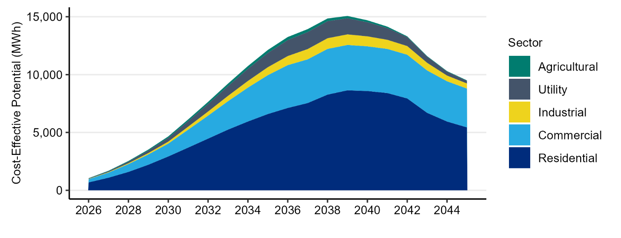

Figure 4 shows how the energy efficiency potential grows on a cumulative basis through the study period, totaling nearly 190,000 MWh over the 20-year planning period.

Figure : Annual Cumulative Cost-Effective Energy Efficiency Potential (MWh)

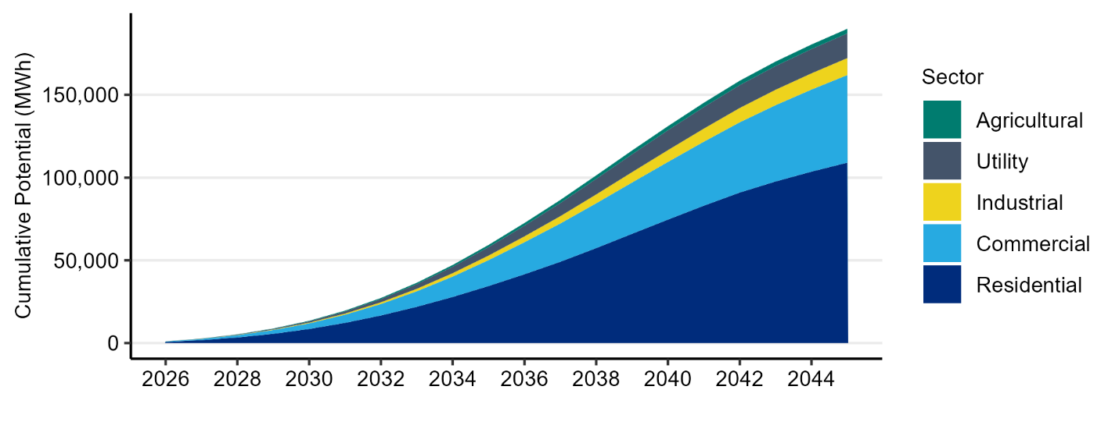

The year-by-year estimates of energy efficiency potential are based on ramp rates developed by the Council. Ramp rates identify the share of each measure’s available potential that is projected to be acquired in each year based on its market and program maturity. For each measure, the project team applied a ramp rate that would align the near-term potential with Inland Power’s recent program achievements and the savings from NEEA’s market transformation initiatives that were estimated to occur in Inland Power’s service territory. Program achievement data was provided by Inland Power staff and the project team assigned appropriate ramp rates to each measure so that the future acquisition of energy efficiency was aligned with recent program history while ensuring the acquisition of all energy efficiency potential over the 20-year planning period.

## Comparison to Previous Assessment

Table 3 shows a comparison of the 2-, 10-, and 20-year cost-effective potential by sector as quantified by the previous 2023 CPA and this 2025 CPA. The near-term potential declined significantly while there were smaller decreases in the long-term potential.

Table : Comparison of 2023 and 2025 CPA Results (MWh)

|  |  |  |  |  |  |  |  |  |  |
| --- | --- | --- | --- | --- | --- | --- | --- | --- | --- |
|  | **2-Year Potential** | | | **10-Year Potential** | | | **20-Year Potential** | | |
| **Sector** | **2023 CPA** | **2025 CPA** | **% Change** | **2023 CPA** | **2025 CPA** | **% Change** | **2023 CPA** | **2025 CPA** | **% Change** |
| Residential | 3,112 | 1,779 | -43% | 47,552 | 34,462 | -28% | 118,483 | 109,057 | -8% |
| Commercial | 1,201 | 719 | -40% | 22,070 | 15,667 | -29% | 61,097 | 52,961 | -13% |
| Industrial | 101 | 64 | -36% | 2,829 | 2,763 | -2% | 7,813 | 10,258 | 31% |
| Utility | 588 | 115 | -81% | 12,891 | 5,063 | -61% | 24,433 | 14,907 | -39% |
| Agricultural | 119 | 64 | -46% | 1,768 | 1,358 | -23% | 3,032 | 2,778 | -8% |
| **Total** | **5,121** | **2,741** | **-46%** | **87,110** | **59,313** | **-32%** | **214,858** | **189,961** | **-12%** |

Overall cost-effective potential is lower compared to the 2023 CPA due to lower market price forecasts that caused more energy efficiency equipment to not meet economic criteria, lower customer forecasts in the commercial and residential sectors, and updated measure assumptions that impacted cost-effectiveness outcomes. In the near-term, these changes are compounded with the impact of slower adoption rates for energy efficiency equipment based on Inland Power’s recent accomplishments and expectations for future savings.

## Conclusion

This report summarizes the CPA conducted for Inland Power for the 2026 to 2045 timeframe. The CPA identified a slightly smaller amount of cost-effective potential relative to the previous CPA. The cost-effective potential identified in this assessment can reduce Inland Power’s annual energy and peak demand by 10% and 15%, respectively.

# Introduction

## Objectives

This report describes the methodology and results of a CPA conducted for Inland Power by the project team. The CPA estimated the cost-effective potential energy savings for the period of 2026 to 2045. This report describes the results of the full 20-year period, with additional detail on the 2- and 10-year periods that are the focus of Washington’s EIA as well as the 4-year period covering 2026-2029 that aligns with Inland Power’s 2025 CEIP.

This assessment was conducted in a manner consistent with the requirements of Washington’s RCW 19.285, and WAC 194-37. As such, this report is part of the documentation of Inland Power’s compliance with these requirements. The state of Washington’s CETA includes an additional requirement for CPAs to use specific values for the social cost of carbon. The required values were incorporated into this analysis.

The results of this assessment can be used to assist Inland Power in planning its energy efficiency programs by identifying the amount of cost-effective energy savings available in various sectors, end uses, and measures.

## Background

Washington State’s EIA defines “qualifying utilities” as those with 25,000 customers or more and requires them to achieve all conservation that is cost-effective, reliable, and feasible. Since Inland Power serves more than 44,000 customers in Washington, it is required to comply with the EIA. The requirements of the EIA specify that all qualifying utilities complete the following by January 1st of every even numbered year:[1]

* Identify the achievable cost-effective conservation potential for the upcoming 10 years using methodologies consistent with the Council’s latest power plan.
* Establish a biennial acquisition target for cost-effective conservation that is no lower than the utility’s pro rata share for that two-year period of its cost-effective conservation potential for the subsequent 10 years.[2]

Appendix III further details how this assessment complies with each of the requirements specified by Washington’s EIA.

## Study Uncertainties

There are uncertainties inherent in any long-term planning effort. While this assessment makes use of the latest forecasts of customers and loads, it is still subject to remaining uncertainties and limitations. These uncertainties include, but are not limited to:

* Customer Characteristic Data: This assessment used the best available data to reflect Inland Power’s customers. In some cases, however, the assessment relied upon data beyond Inland Power’s service territory due to limitations of adequate sample sizes. There are uncertainties, therefore, related to the extent that this data is reflective of Inland Power’s customer base.
* Measure Data: Measure savings and cost estimates are based on values prepared by the Council and RTF. These estimates will vary across the region due to local climate variations and market conditions. Additionally, some measure inputs such as applicability are based on limited data or professional judgement.
* Market Price Forecasts: This assessment uses an updated market price forecast developed in July of 2025. While this is an up-to-date forecast, market prices and forecasts are continually changing.
* Utility System Assumptions: Measures in this CPA receive cost credits based on their ability to free up transmission and distribution system capacity. The actual value of these credits is dependent on local conditions, which vary across Inland Power’s service territory.
* Load and Customer Growth Forecasts: This CPA uses projections of future customer and load growth over a 20-year period. Any forecast over a similar time period will include a significant level of uncertainty.
* Policy Changes: The CPA reflects policies currently in effect at the time of its development. Future changes to the policy environment are difficult to predict and could lead to significant changes to loads, cost effectiveness of measures, or other study outcomes.

Due to these uncertainties and the continually changing planning environment, the EIA requires qualifying utilities to update their CPAs every two years to reflect the best available data and latest market conditions.

## Report Organization

The remainder of this report is organized into the following sections:

* Methodology
* Customer Characteristics
* Recent Conservation Achievement
* Results
* Sensitivity Results
* Summary
* References & Appendices

# Methodology

This section provides an overview of the methodology used to develop the estimate of cost-effective conservation potential for Inland Power.

Washington’s requirements for CPAs are spelled out in RCW 19.285.040 and WAC 194-37-070, Section 5 parts (a) through (d). Additional requirements are specified in the rules of Washington’s CETA. The methodology used to produce this assessment is consistent with these requirements and follows much of the methodology used by the Council in developing its regional power plans, including the 2021 Power Plan.

Appendix III provides a detailed breakdown of the requirements of the EIA and how this assessment complies with those requirements.

## High-level Methodology

The methodology used for this assessment is illustrated in Figure 5. At a high level, the process combines data on individual energy efficiency measures and economic assumptions using the Council’s ProCost tool. This tool calculates a benefit-cost ratio using the Total Resource Cost (TRC) test, which is used to determine whether a measure is cost-effective. The TRC test considers all of the costs and benefits of energy efficiency measures, regardless of who receives the benefit or pays the cost. The measure savings and economics are then combined with customer data in Lighthouse’s CPA model, which quantifies the number of remaining implementation opportunities. The CPA model aggregates the savings associated with each of these opportunities to determine the overall potential.

Figure : Conservation Potential Assessment Methodology

## Economic Inputs

The project team worked closely with Inland Power staff to define the economic inputs that were used in this CPA, including avoided energy costs, carbon costs, transmission and distribution capacity costs, and generation capacity costs. Each of these are discussed below. A full discussion of the avoided costs is included in Appendix IV.

### Avoided Energy Costs

Avoided energy costs represent the cost of energy purchases that are avoided through energy efficiency savings. The EIA requires utilities to “set avoided costs equal to a forecast of regional market prices.”[3] For this CPA, Inland Power provided a forecast of on- and off-peak market prices at the Mid-Columbia trading hub that served as the basis for this forecast. Figure 6 below shows the market price forecast that was used for the base case of this assessment. High and low sensitivity price forecasts were developed based on this forecast and are discussed in Appendix IV.

Figure 6: Avoided Energy Costs

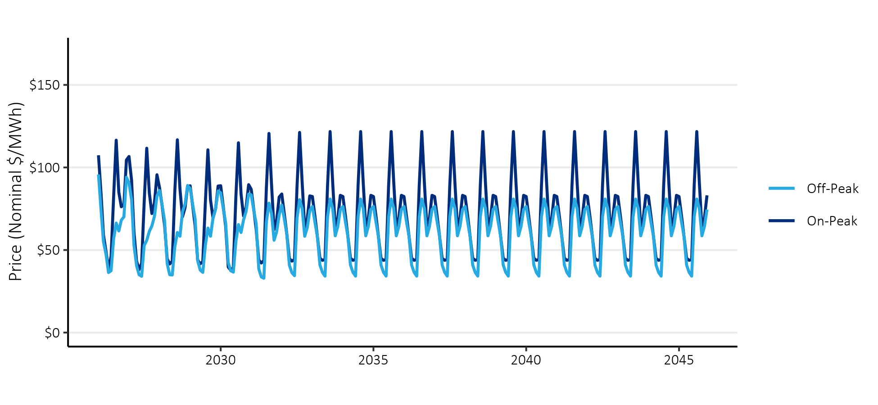

### Social Cost of Carbon

In addition to avoiding purchases of energy, energy efficiency measures can avoid emissions of greenhouse gases like carbon dioxide. The EIA requires that CPAs include a social cost of carbon, which the US EPA defines as “a measure of the long-term damage done by a ton of carbon dioxide emissions in a given year.” It includes, among other things, changes in agricultural productivity, human health, property damages from increased flood risk, and changes in energy system costs, including increases in the costs of cooling and decreases in heating costs.[4] In addition to this requirement, Washington’s CETA requires that utilities use the social cost of carbon values developed by the federal Interagency workgroup using a 2.5% discount rate.[5]

### Renewable Portfolio Standard Compliance Costs

By reducing Inland Power’s overall load, energy efficiency reduces the cost of complying with Washington’s requirements for renewable and carbon-neutral energy. In 2026, Inland Power is required to source 15% of its sales from renewable energy. With a 15% requirement for renewable energy, Inland Power can avoid the purchase of 15 Renewable Energy Credits (RECs) with every 100 MWh of energy savings. In 2030, CETA requires all sales to be greenhouse gas neutral, while allowing up to 20% of the requirement to be met through REC purchases through 2044. Based on this requirement, it is assumed that after 2030 every unit of energy savings results in an equivalent reduction in REC purchases. In 2045, CETA requires 100% clean energy, so the project team assumed that market prices plus REC costs would represent the cost of clean energy.

### Deferred Transmission and Distribution System Costs

Unlike supply-side resources, energy efficiency does not require capacity on transmission and distribution infrastructure. Instead, it frees up capacity by reducing the peak demands on these systems and can help defer future capacity expansions and the associated capital costs.

In the development of the 2021 Power Plan, the Council developed a standard methodology for calculating these values and surveyed Northwest utilities to update the values associated with these cost deferrals. This CPA uses the values developed by the Council through that process. The resulting values are $3.54 and $7.82 per kW-year (in 2016 dollars) for transmission and distribution capacity, respectively.[6] These values are applied to the demand savings coincident with the timing of the respective system peaks.

### Program Administration Costs

In its past power plans, the Council has assumed that program administrative costs are equal to 20% of the cost of each measure. This CPA uses that assumption, which is also consistent with Inland Power’s previous CPAs.

### Risk Mitigation

Investing in energy efficiency can reduce the risks that utilities face by the fact that it is made in small increments over time, rather than the large, singular sums required for generation resources.

This CPA follows the process used in Inland Power’s previous CPAs. A sensitivity analysis is used to account for uncertainty, where present, in avoided cost values. The variation in inputs covers a range of possible outcomes and the amount of cost-effective energy efficiency potential is presented under each sensitivity. In selecting its biennial target based on this range of outcomes, Inland Power is selecting its preferred risk strategy and the associated risk credit.

### Northwest Power Act Credit

The EIA requires that a 10% cost credit be given to energy efficiency measures. This benefit is specified in the Northwest Electric Power Planning and Conservation Act and is included by the Council in their power planning work.

## Other Financial Assumptions

In addition, this assessment makes use of an assumed discount rate to convert future costs and benefits to present values so that values occurring in different years can be compared. This assessment uses a real discount rate of 3.75%. Energy efficiency’s benefits accrue over the lifetime of the measure, so a lower discount rate results in higher present values for benefits occurring in future years.

Assumptions about finance costs are applied to measures as well. The cost of each measure is assumed to be split across various entities, including Bonneville Power Administration (BPA), Inland Power, and end use customers. For each of these entities, additional assumptions are made about whether the measure costs are financed, and if so, the cost of that financing. This assessment uses the finance cost assumptions that were used in the 2021 Power Plan.

## Measure Characterization

Measure characterization is the process of defining each individual measure, including the savings at the meter as well as the cost, lifetime, non-energy impacts, and a load or savings shape that defines when the savings occur. The Council’s 2021 Power Plan materials are the primary source for this information, although the project team incorporated updated information from the RTF for many measures. Appendix V contains the full list of energy efficiency measures considered the source(s) of information used for each.

Measure savings are typically defined via a “last in” approach. With this methodology, each measure’s savings is determined as if it was the last measure installed. For example, savings from home weatherization measures are determined based on the assumption that the home’s heating system has already been upgraded. Similarly, the heating system measures are quantified based on the assumption that the home has already been weatherized. This approach is conservative but prevents double counting savings over the long term as homes are likely to install both measures.

Measure savings also consider measure interaction. Interaction occurs when measures in one end use impact the energy use of other end uses. Examples of this include energy efficient lighting and other appliances. The efficiency of these appliances results in less wasted energy released as heat, which impacts the demands on heating and cooling systems.

These measure characteristics, along with the economic assumptions, are used as inputs to the Council’s ProCost tool. This tool determines the savings at the generator, factoring in line losses, as well as the demand savings that occur coincident with Inland Power’s system peak. The outputs of ProCost are used to calculate each measure’s levelized cost and benefit-cost ratio, the latter of which is used to determine whether the measure is cost-effective.

## Customer Characteristics

The assessment of customer characteristics is used to determine the number of remaining measure installation opportunities for each measure. This requires identifying the number of opportunities overall as well as the share that has already been completed. The characterization of Inland Power’s customer base was completed primarily using data provided by Inland Power, NEEA’s commercial and residential building stock assessments, and US Census data. Additional data sources and further details by sector are described subsequently in this report.

This CPA used baseline measure saturation data from the Council’s 2021 Power Plan. This data was developed from NEEA’s stock assessments, market research, and other studies. This data was supplemented with Inland Power’s conservation achievements, where applicable. This achievement is discussed in the next section.

## Energy Efficiency Potential

The energy efficiency measure data and customer characteristics are combined in Lighthouse’s CPA model. The model estimates the economic (or cost-effective) energy efficiency savings potential as a subset of the technical and achievable potential based on the process shown in Figure 7. Each type of potential is discussed in further detail below.

Figure : Types of Energy Efficiency Potential



First, technical potential is the theoretical maximum of energy efficiency available, regardless of cost or market constraints. It is determined by multiplying the measure savings by the number of remaining feasible installation opportunities.

The model then applies several filters that incorporate market and adoption barriers to estimate the achievable potential. These filters include assumptions about the maximum potential adoption and the pace of annual achievements. Energy efficiency planners generally assume that not all measure opportunities will be installed; some portion of the technically possible measure opportunities will remain unavailable due to unsurmountable barriers. In the Northwest, energy efficiency planners typically assume that 85% of all measure opportunities can be achieved. This assumption comes from a pilot study conducted in Hood River, Oregon, where home weatherization measures were offered at no cost. The pilot was able to reach over 90% of homes and complete 85% of identified measure opportunities.[7] In the 2021 Power Plan, the Council has taken a more nuanced approach to this assumption. Measures that are likely to be subject to future codes or product standards have higher maximum achievability assumptions. This CPA follows the Council’s new approach.

In addition, ramp rates are used to identify the portion of the available potential that can be acquired each year. The selection of ramp rates incorporates the different levels of program and market maturity as well as the practical constraints of what utility programs can accomplish in a given year.

Finally, economic potential is determined by limiting the achievable potential to those measures that pass an economic screen. Per the EIA, this assessment uses the TRC test to determine economic potential. The TRC test considers all measure costs and benefits, regardless of who pays the cost or receives the benefit. The costs and benefits include the full incremental capital cost of the measure, any operations and maintenance costs, program administrative costs, avoided energy and carbon costs, deferred capacity costs, and quantifiable non-energy impacts. Because the TRC test considers the full cost of energy efficiency measures, Inland Power could pay up to the full cost of measures with its incentives without impacting the cost effectiveness. However, practical constraints such as annual program budgets and rate impacts may limit this.

# Customer Characteristics

This section describes the characterization of Inland Power’s customers, which is an essential component of a CPA. It includes defining the makeup and characteristics of each sector, which determines the type and quantity of opportunities to implement energy efficiency measures. Additional information about the local climate and population of the service territory is used to characterize certain measures. This information is summarized in Table 4.

Table : Service Territory Characteristics

|  |  |  |  |
| --- | --- | --- | --- |
| **Heating Zone** | **Cooling Zone** | **Total Homes (2024)** | **Total Population (2023)** |
| 2 | 2 | 40,607 | 89,471 |

The number of homes was based on data reported to the US Energy Information Administration (US EIA) and is less than a 1% decrease relative to the initial value used in Inland Power’s 2023 CPA. The number of homes was projected to grow at 1.9%, based on the long-term trend of customer growth. This is an increase from the growth rate assumption used in the 2023 CPA, 1.5%.

Additionally, a demolition rate, based on assumptions for Washington State from the Council’s 2021 Power Plan, was also used. The demolition rate quantifies the number of existing homes that are converted to new homes through demolition or major renovations, where building codes for new homes apply.

The population is based on census estimates for Inland Power service area zip codes in Washington.

## Residential

Within the residential sector, the key characteristics are the number and type of homes as well as the saturation of end use appliances such as space and water heating equipment. Table 5 and Table 6 summarize the characteristics that were used for this assessment for existing and new homes, respectively.

Table : Residential Existing Home Characteristics

|  |  |  |  |  |
| --- | --- | --- | --- | --- |
|  | **Single Family** | **Low Rise Multifamily** | **High Rise Multifamily** | **Manufactured** |
| Share of Homes | 74% | 8% | 7% | 11% |
| **HVAC Equipment** |  |  |  |  |
| Electric Forced Air Furnace | 15% | 13% | 13% | 49% |
| Air Source Heat Pump | 23% | 0% | 0% | 22% |
| Ductless Heat Pump | 6% | 6% | 6% | 0% |
| Electric Zonal/Baseboard | 9% | 51% | 51% | 3% |
| Central Air Conditioning | 36% | 11% | 11% | 23% |
| Room Air Conditioning | 13% | 64% | 64% | 29% |
| **Other Appliances** |  |  |  |  |
| Electric Water Heater | 63% | 78% | 78% | 91% |
| Refrigerator | 152% | 99% | 99% | 132% |
| Freezer | 104% | 26% | 26% | 96% |
| Clothes Washer | 99% | 75% | 75% | 96% |
| Electric Clothes Dryer | 93% | 74% | 74% | 93% |
| Dishwasher | 97% | 78% | 78% | 83% |
| Electric Oven | 72% | 97% | 97% | 89% |
| Desktop | 66% | 21% | 19% | 31% |
| Laptop | 83% | 75% | 70% | 66% |
| Monitor | 120% | 50% | 52% | 34% |

Table : Residential New Home Characteristics

|  |  |  |  |  |
| --- | --- | --- | --- | --- |
|  | **Single Family** | **Low Rise Multifamily** | **High Rise Multifamily** | **Manufactured** |
| **HVAC Equipment** |  |  |  |  |
| Electric Forced Air Furnace | 0% | 13% | 13% | 49% |
| Air Source Heat Pump | 38% | 0% | 0% | 22% |
| Ductless Heat Pump | 14% | 6% | 6% | 0% |
| Electric Zonal/Baseboard | 0% | 51% | 51% | 3% |
| Central Air Conditioning | 36% | 11% | 11% | 23% |
| Room Air Conditioning | 13% | 64% | 64% | 29% |
| **Other Appliances** |  |  |  |  |
| Electric Water Heater | 63% | 78% | 78% | 91% |
| Refrigerator | 152% | 99% | 99% | 132% |
| Freezer | 104% | 26% | 26% | 96% |
| Clothes Washer | 99% | 75% | 75% | 96% |
| Electric Clothes Dryer | 93% | 74% | 74% | 93% |
| Dishwasher | 97% | 78% | 78% | 83% |
| Electric Oven | 72% | 97% | 97% | 89% |
| Desktop | 66% | 21% | 19% | 31% |
| Laptop | 83% | 75% | 70% | 66% |
| Monitor | 120% | 50% | 52% | 34% |

In these tables, numbers greater than 100% imply an average of more than one appliance per home. For example, the single family refrigerator saturation of 152% means that single family homes average 1.52 refrigerators per home.

For this assessment, the project team used 2020 survey data analysis conducted by Lighthouse for Inland Power in combination with the latest information from NEEA’s 2022 Residential Building Stock Assessment (RBSA), which was not available at the time the 2023 CPA was developed.

## Commercial

In the commercial sector, the building floor area is the primary variable in determining the number of conservation opportunities, as many of the commercial measures are quantified based on the applicable amount of floor area. To estimate the commercial floor area in Inland Power’s service territory, the project team mapped Inland Power’s 2024 non-residential customer account sales to commercial and industrial building types. The project team then converted the commercial sales to estimates of floor area using average energy use intensities from the 2019 Commercial Building Stock Assessment.

Table 7 summarizes the resulting floor area estimates for each of the 18 commercial building segments. The total commercial floor area was estimated to be just below 20 million square feet, a 6% increase over the baseline floor area used in the 2023 CPA.

Table : Commercial Floor Area by Segment

|  |  |
| --- | --- |
| Building Type | 2024 Floor Area (square feet) |
| Large Office | 660,733 |
| Medium Office | 217,478 |
| Small Office | 198,824 |
| Extra Large Retail | 957,101 |
| Large Retail | 155,721 |
| Medium Retail | 204,678 |
| Small Retail | 124,645 |
| School (K-12) | 2,919,701 |
| University | 50,058 |
| Warehouse | 12,677,912 |
| Supermarket | 94,466 |
| Mini Mart | 17,048 |
| Restaurant | 53,738 |
| Lodging | 461,908 |
| Hospital | - |
| Residential Care | 12,467 |
| Assembly | 689,815 |
| Other Commercial | 453,226 |
| Total | 19,949,520 |

The project team assumed a growth rate of 2.6% in the commercial sector based on historical, non-residential sales trends reported to the US EIA. This is a decrease from the 2023 CPA’s assumed growth rate of 2.9%.

## Industrial

The methodology used to estimate potential in the industrial sector is different from the residential and commercial sectors. Instead of building a bottom-up estimate of the savings associated with individual measures, potential in the industrial sector is quantified using a top-down approach that uses the annual energy consumption within individual industrial segments, which is then further disaggregated into end uses. Savings for individual measures are calculated by applying an assumed savings percentage to the applicable end use consumption within each industrial segment.

Inland Power provided non-residential customer account sales for 2024 that the project team mapped to the commercial and industrial building types. Based on this mapping, the aggregate 2024 industrial consumption was estimated at 54,336 MWh and is summarized by building type in Table 8. This is a 20% increase from the 2023 CPA, because in the 2023 CPA grain storage facilities were excluded. For this CPA, the project team incorporated these sites under the miscellaneous manufacturing segment where the energy efficiency savings opportunities are most consistent with that of a grain storage facility.

The project team assumed that industrial loads would grow at a rate of 2.6%, based on the historical non-residential sector growth for Inland Power’s Washington customers. This is a slight decrease from the growth rate of 2.9% assumed in the 2023 CPA. Although the growth rate is lower, industrial loads are still projected to be higher than in the 2023 CPA due to the greater base year sales identified in the industrial sector.

Table : Industrial Sector Sales by Segment

|  |  |
| --- | --- |
| Segment | 2024 Sales (MWh) |
| Water Supply | 5,300 |
| Sewage Treatment | 3,218 |
| Frozen Food | - |
| Other Food | 539 |
| Wood - Lumber | - |
| Wood - Panel | - |
| Wood - Other | - |
| Pulp and Paper Mills (TMP) | - |
| Pulp and Paper Mills (Kraft) | - |
| Paper Conversion Plants | - |
| Refinery | - |
| Chemical Manufacturing | 41 |
| Silicon Growing/Manufacturing | - |
| Cement/Concrete Products | 4,275 |
| Primary Metal Manufacturing | - |
| Fabricated Metal Manufacturing | 7,316 |
| Semiconductor Manufacturing | - |
| Transportation Equipment | 233 |
| Misc. Manufacturing | 9,498 |
| Refrigerated Warehouse | 1,406 |
| Fruit Storage | 5,062 |
| Indoor Agriculture | 17,448 |
| **Total** | **54,336** |

## Utility Distribution System

The 2021 Power Plan used a new approach for quantifying the potential energy savings in measures that improve the efficiency of utility distribution systems. The Council’s new approach estimated savings potential from the 2018 sales within each sector as reported to the US EIA and based costs on the estimated number of distribution substations and feeders for each utility. Table 9 summarizes the assumptions used for this sector.

Table : Utility Distribution System Efficiency Assumptions

|  |  |
| --- | --- |
| **Characteristic** | **Count** |
| Distribution Substations | 17 |
| Residential/Commercial Substations | 15 |
| Urban Feeders | 22 |
| Rural Feeders | 12 |
| 2018 Residential Sales (MWh) | 656,947 |
| 2018 Commercial Sales (MWh) | 167,846 |
| 2018 Industrial/Other Sales (MWh) | 90,710 |

*\*Note that these are estimates from the Council and may not reflect Inland Power’s actual system*

# Recent Conservation Achievement

Inland Power has a long history of energy efficiency achievement and, according to the RTF’s Regional Conservation Progress Report, has achieved annual savings equal to 0.6% of its retail sales on average over the 2016-2023 timeframe.

Inland Power currently offers programs for its residential, commercial, industrial, and agricultural customers. In addition to these programs, Inland Power receives credit for the market transformation initiatives of NEEA that accrue within its service territory. NEEA’s work has helped to bring energy efficient emerging technologies, like ductless heat pumps and heat pump water heaters, to the Northwest.

## Overall

Figure 8 summarizes Inland Power’s 2012-2023 conservation achievement by sector as well as the savings attributed to NEEA, as reported under Washington’s EIA.

Figure : Past Conservation Achievements by Sector (MWh)

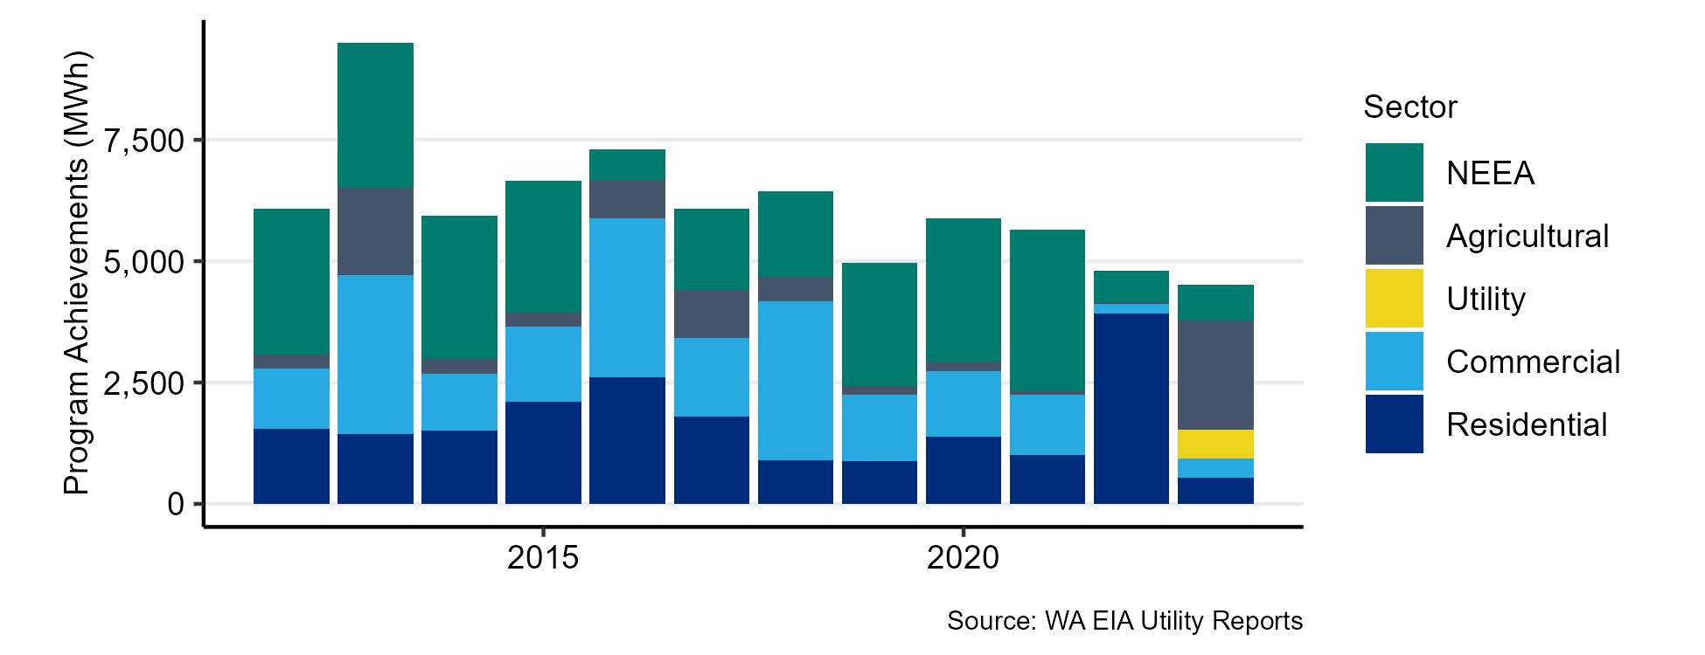

The average annual savings over this 12-year period is approximately 6,150 MWh per year. Savings from NEEA’s market transformation initiatives are primarily in the residential sector. Savings from NEEA decreased in 2022 when the baselines that are used to quantify its market transformation efforts were reset to align with the 2021 Power Plan. A similar adjustment happened in 2016.

Inland Power provided detailed program achievement data for 2023 and 2024. The sections below summarize these recent achievements. Note that discrepancies may exist between the reported EIA values and the following more detailed accomplishment data due to differences in reporting timelines, differences in sector definitions and the exclusion of certain measures reported under the EIA that are not included in this CPA.

## Residential

The recent residential program achievements by end use are shown in Figure 9. The savings total approximately 884 MWh over the two years. The HVAC end use is the largest end use, at nearly 80% of the total. This end use includes both weatherization measures as well as heating system equipment. Outside of HVAC, Inland Power has achieved savings in the water heating and appliances end uses, in addition to savings from new homes, which are listed in the whole home end use.

Figure : Recent Residential Program Achievements by End Use (MWh)

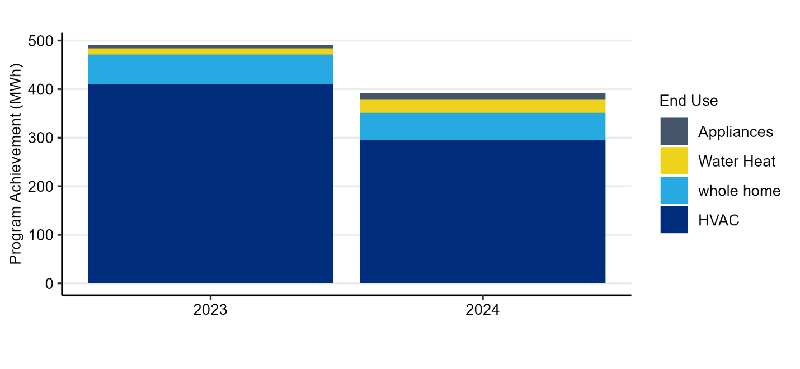

## Commercial

Inland Power’s commercial savings are primarily from the lighting end use, as shown in Figure 10. In total, commercial savings were more than 583 MWh over the two-year period.

Figure : Recent Commercial Program Achievements by End Use

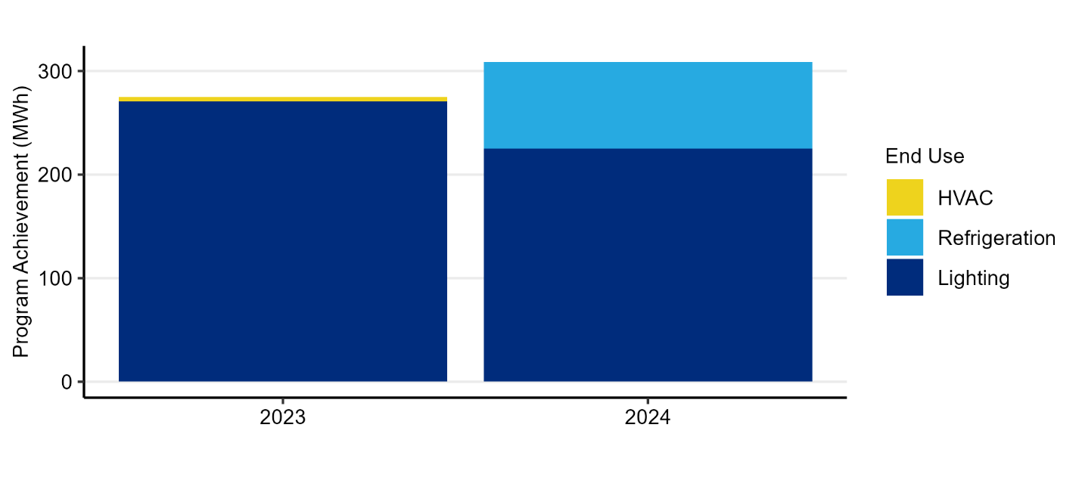

## Industrial

Inland Power’s industrial sector is relatively small. Loads related to indoor agriculture operations comprise more than 40% of all industrial loads. Inland Power’s programs have little traction in the industrial sector, and some projects may be categorized under the commercial schedule. Therefore, the only historical savings quantified were from a 2023 industrial refrigeration project that provided approximately 81 MWh in savings. This is shown in Figure 11.

Figure : Recent Industrial Program Achievements by End Use

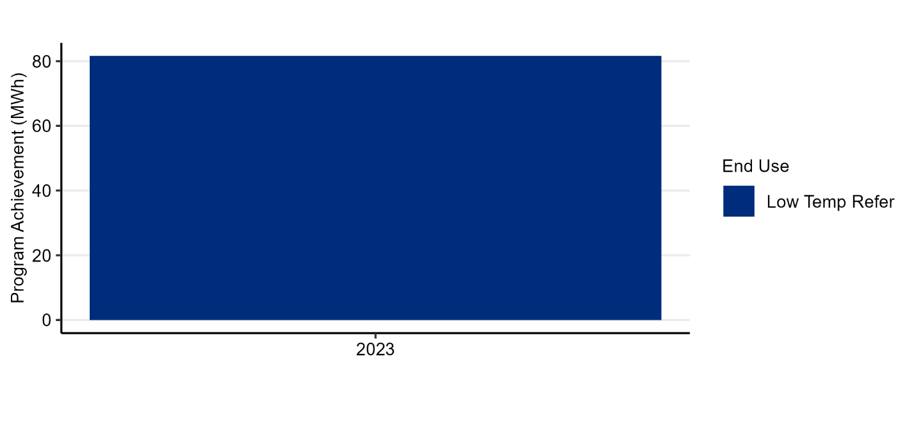

## Agricultural

Similarly to the industrial sector, Inland Power’s historical agricultural conservation savings are more limited. Figure 12 shows the accomplishments applicable to the CPA in the irrigation end use. This does not include savings from Inland Power’s thermostatically controlled outlet program, which was excluded given that the CPA does not quantify potential for this measure. Savings from this measure totaled more than 2,000 MWh in 2023.

Figure : Recent Agricultural Program Achievements by End Use

# Results

This section discusses the results of the 2025 CPA. It begins with a discussion of the high-level achievable conservation potential and then covers additional detail on the cost-effective potential within the individual sectors and end uses.

## Achievable Conservation Potential

The achievable technical conservation potential is the amount of energy efficiency that can be saved without considering the cost-effectiveness of measures. It considers market barriers and the practical limits of acquiring energy savings through efficiency programs.

Figure 13 shows the supply curve of achievable potential over the 20-year study period. A supply curve depicts the cumulative potential against the levelized cost of energy savings, with measures sorted in order of ascending cost. No economic screening is applied. Levelized costs are used to make the costs comparable between measures with different lifetimes as well as with supply-side resources. The costs include credits for deferred transmission and distribution system costs, avoided periodic replacements, and non-energy impacts to make them comparable with other resources. With these credits, some of the lowest cost measures have a net levelized cost that is negative, meaning the credits exceed the measure costs.

Figure : 20-Year Supply Curve

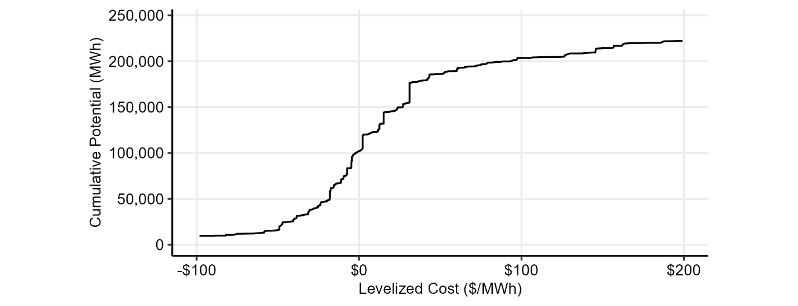

Figure 13 shows that approximately 100,000 MWh of potential are available at a cost at or below $0/MWh. Roughly 185,000 MWh of achievable potential are available for costs below $50/MWh. In total, there is more than 244,000 MWh of achievable technical potential available in Inland Power’s service territory over the 20-year study period, but only potential below $200/MWh is shown.

Supply curves based on levelized cost are limited in that not all energy savings are equally valued. For example, two measures could have the same levelized cost but provide different reductions in peak demand or deliver energy savings when energy costs are more or less valuable. An alternative to the supply curve based on levelized cost is one based on the benefit cost ratio. This is shown below in Figure 14.

Figure 14: 20-Year Benefit-Cost Ratio Supply Curve

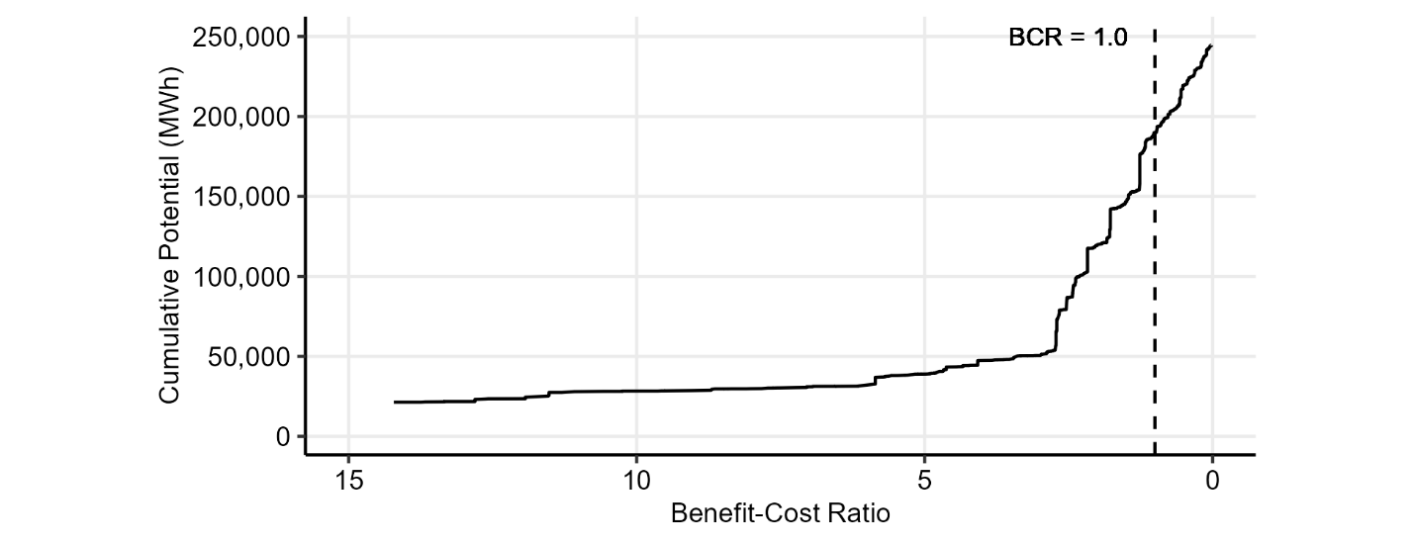

Figure 14 shows that approximately 40,000 MWh of savings are available with a benefit-cost ratio of 5 or more. These measures deliver benefits that are 5 times their cost over their lifetime. The figure includes a dashed line where the benefit-cost ratio is equal to one. There is over 189,000 MWh of cost-effective savings potential to the left of this line, reflecting the 20-year cost-effective potential.

The economic or cost-effective potential is described below.

## Cost-Effective Conservation Potential

Figure 15 shows the cost-effective potential by sector on an annual basis. Over the 20-year period, most of the potential is in Inland Power’s residential and commercial sectors.

Figure : Annual Cost-Effective Potential by Sector



The project team used the ramp rates from the 2021 Power Plan to establish reasonable rates of acquisition for all measures and sectors. The project team assigned ramp rates to individual measures in order to align the near-term potential with recent and expected savings in each sector. Appendix VII has more detail on the alignment of ramp rates with program expectations.

The sections below describe the achievable potential within each sector.

### Residential

Relative to the 2023 CPA, the cost-effective potential in the residential sector has decreased. Despite increases in the number of homes and projected growth rate lower avoided costs and updated measure assumptions have resulted in less cost-effective potential.

Figure 16 shows the cost-effective potential by end use for the first 10 years of the study period. HVAC measures (including weatherization) make up 43% of the potential in the sector, followed by appliances (25%), water heating (23%), lighting (4%), and electronics (4%). In Figure 16, the other end use category primarily includes cooking measures.

Figure : Annual Residential Potential by End Use

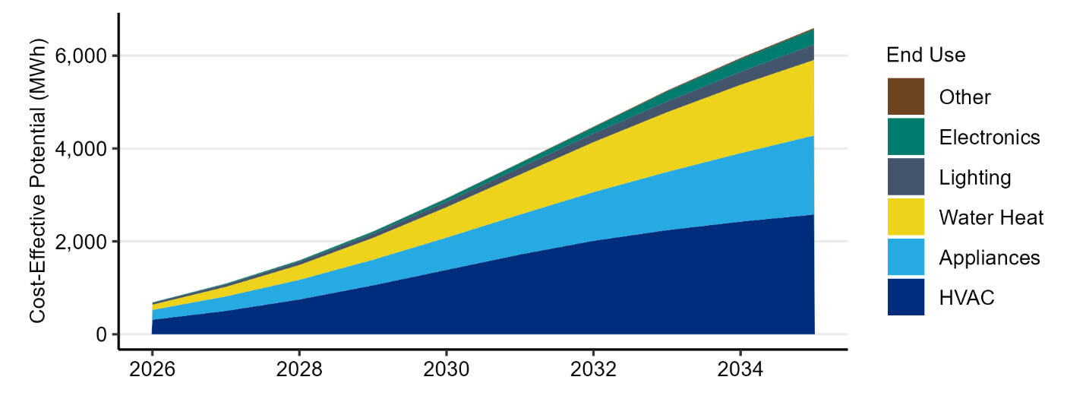

The potential grows through the initial years of the study as the expected market share of efficient equipment increases along with increases in the rate of the acquisition of retrofit measures, like attic insulation, which can be achieved at any time.

Note that some residential measures, such as smart thermostats and heat pump water heaters can provide benefits as both energy efficiency and demand response resources. Demand response benefits were not included in this CPA. The decision to use them as demand response resources was treated as an incremental decision and included in Inland Power’s Demand Response Potential Assessment, although energy efficiency programs can help build a stock of flexible equipment that could be called upon in the future through demand response programs.

Figure 17 shows how the 10-year potential breaks down into end uses and measure categories. The area of each block represents the share of the total 10-year residential potential. Smart thermostats, air source heat pumps (ASHP), and weatherization measures make up most of the potential in the HVAC end use, while heat pump water heaters (HPWH) are the key measure in the water heating end use. The appliance category includes clothes washers, dryers, refrigerators, and freezers.

The project team included incentives from IRA programs in the ASHP costs, improving the cost-effectiveness of this measure, especially relative to prior CPAs. Ductless heat pumps were not cost-effective after updating the measure with the latest RTF assumptions.

Beginning in 2029, heat pump water heaters are subject to a federal standard that will require the technology for many common tank sizes. As there are questions on possible loopholes that leave the future role of utility programs in question, the project team kept the savings potential for these measures after 2029 to show the savings that are possible and will be seen on Inland Power’s system, whether they are achieved through Inland Power’s programs or the federal standard. The state of this market can be re-evaluated in Inland Power’s 2027 CPA.

Figure : Residential Potential by End Use and Measure Category

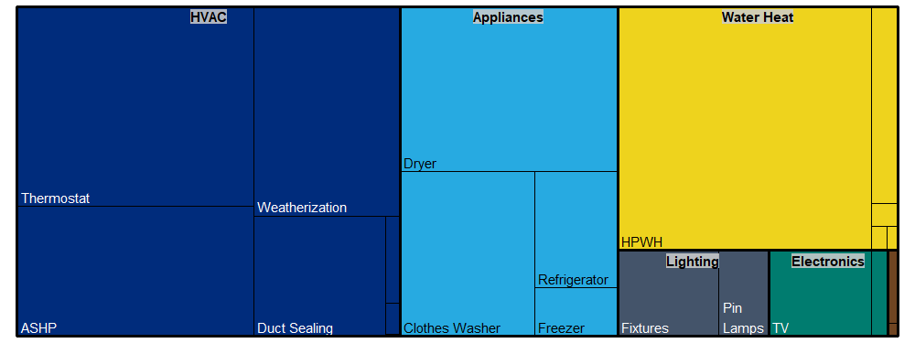

### Commercial

In commercial sector, lighting and HVAC measures are the end uses with the highest potential. These two end uses comprise 42% and 18% of the 10-year potential, respectively. The lighting end use includes measures applicable to both interior and exterior lighting.

Like the residential sector, the potential in the commercial sector has declined relative to the 2023 CPA. This is primarily driven by the change in forecasted commercial floor area and recent decreases in program activity. In addition, the savings potential in the lighting end use is subject to a state law banning mercury in lighting beginning in 2029. In effect, this will raise the baseline for commercial lighting programs to LED products. The project team reduced the lighting savings beginning in 2029 to reflect this change. In addition, the potential remaining in this end use is limited after accounting for Inland Power’s previous achievements.

Figure 18 shows the annual potential in each end use over the first ten years of the study. The figure shows how the new lighting potential after 2029 is more limited while other end uses continue to steadily acquire more savings. Note that the other end use category includes measures in the compressed air, food preparation, process loads, and water heating end uses.

Figure : Annual Commercial Potential by End Use

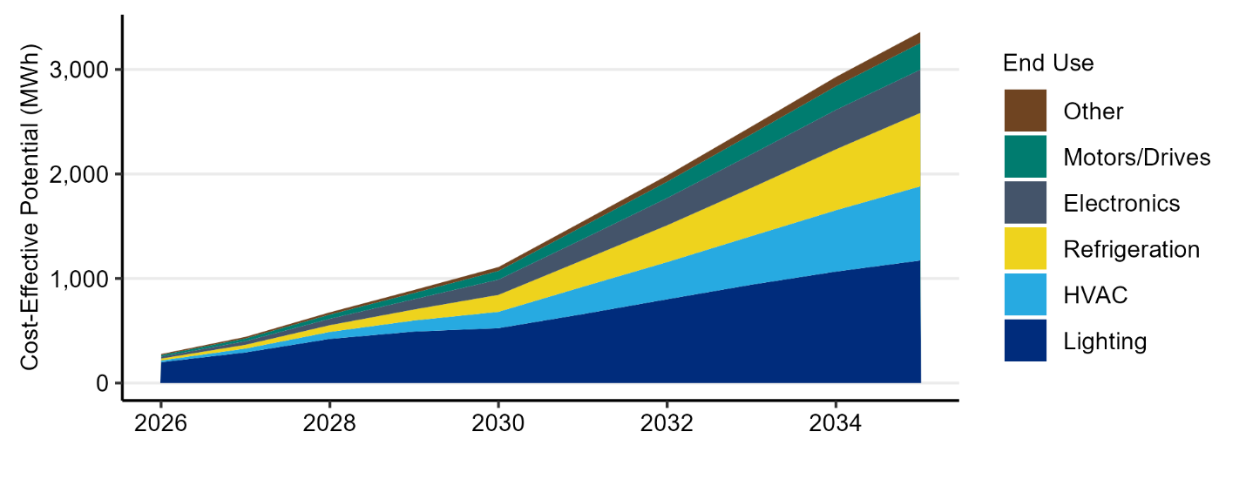

Key end uses and measure categories within the commercial sector are shown in Figure 19. The area of each block is proportional to its share of the 10-year commercial potential. The commercial sector includes a variety of building types with different end uses. This is apparent in the range of measures included in Figure 19, especially the different types of HVAC equipment.

Figure : Commercial Potential by End Use and Measure Category

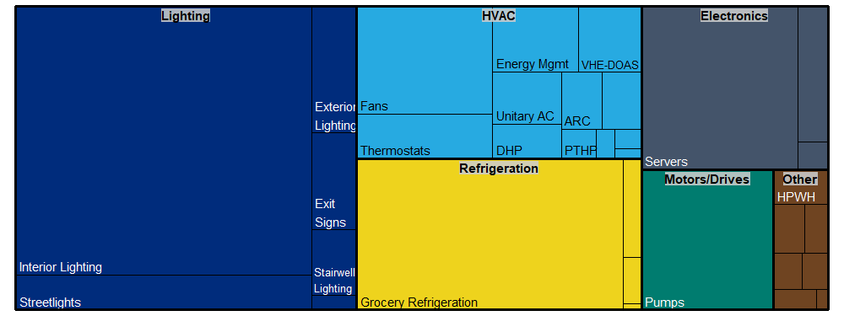

### Industrial

The annual industrial sector potential is shown in Figure 20. The “all electric” and lighting end uses are the largest areas of potential, comprising 33% and 31% of the 10-year potential, respectively. The “all electric” end use category includes measures applicable to all end uses, such as strategic energy management programs, forklift chargers, and measures applicable to the water and wastewater segments. After these end uses, the key end uses include pumps (13%), refrigeration (9%), and fans and blowers (5%). The other category in Figure 20 includes a variety of end uses, including compressed air, material handling and processing, motors, and several other smaller end uses.

The industrial potential near-term potential decreased relative to Inland Power’s 2023 CPA after accounting for recent program accomplishments and incorporating lower avoided costs, but the long term potential increased due to addition of loads from grain storage facilities, which were previously excluded.

Figure : Annual Industrial Potential by End Use

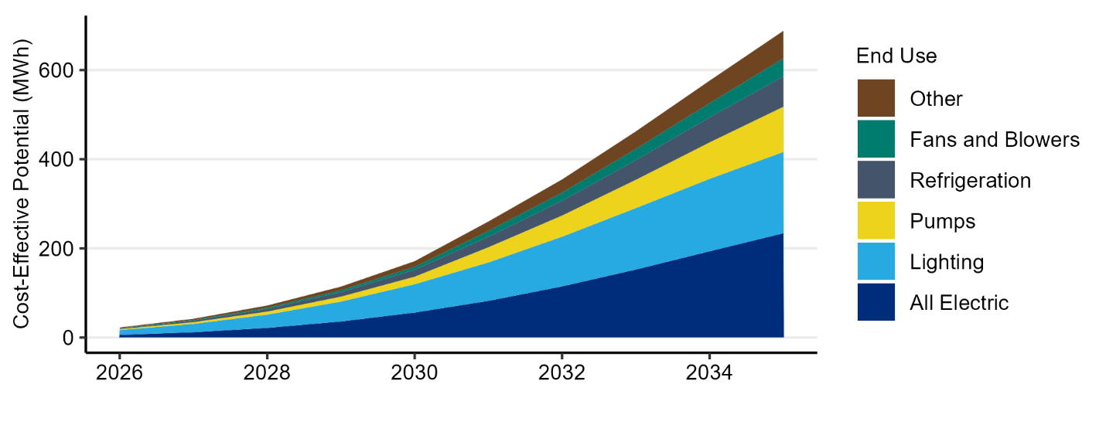

The breakdown of 10-year industrial potential into end uses and measure categories is shown in Figure 21.

Figure : Industrial Potential by End Use and Measure Category

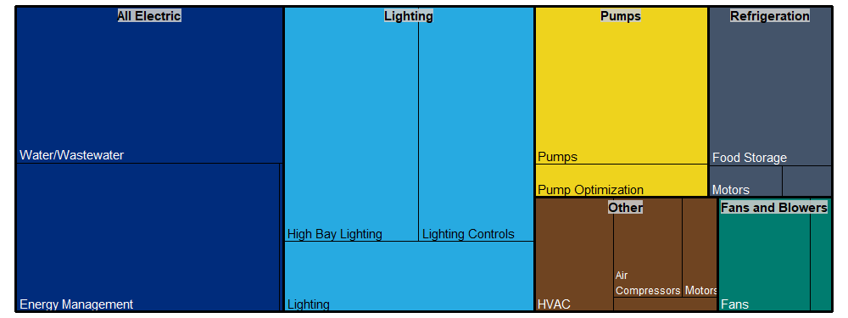

### Utility Distribution System

The measures in the distribution efficiency sector involve the regulation of voltage to improve the efficiency of utility distribution systems. This analysis includes the measures characterized in the 2021 Power Plan, which includes several levels that use increasingly sophisticated control systems.

The annual distribution system potential is shown in Figure 22.

Figure : Annual Distribution System Potential

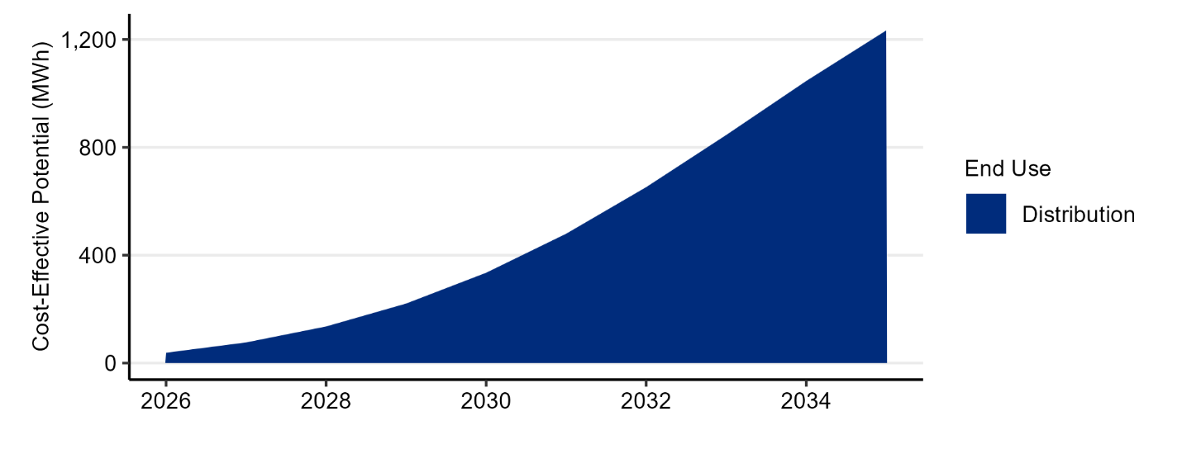

### Agricultural

The potential in the agricultural sector is driven by the irrigated acreage, number of pumps, annual dairy production, and number of farms in the Inland Power’s service territory. Note, the scale used in Figure 23 has changed significantly from what was used in other figures above.

The project team updated the estimate of agricultural potential with the newly available 2022 Census of Agriculture. The overall result was a 8% decrease in 20-year cost-effective potential.

Figure : Annual Agricultural Potential by End Use

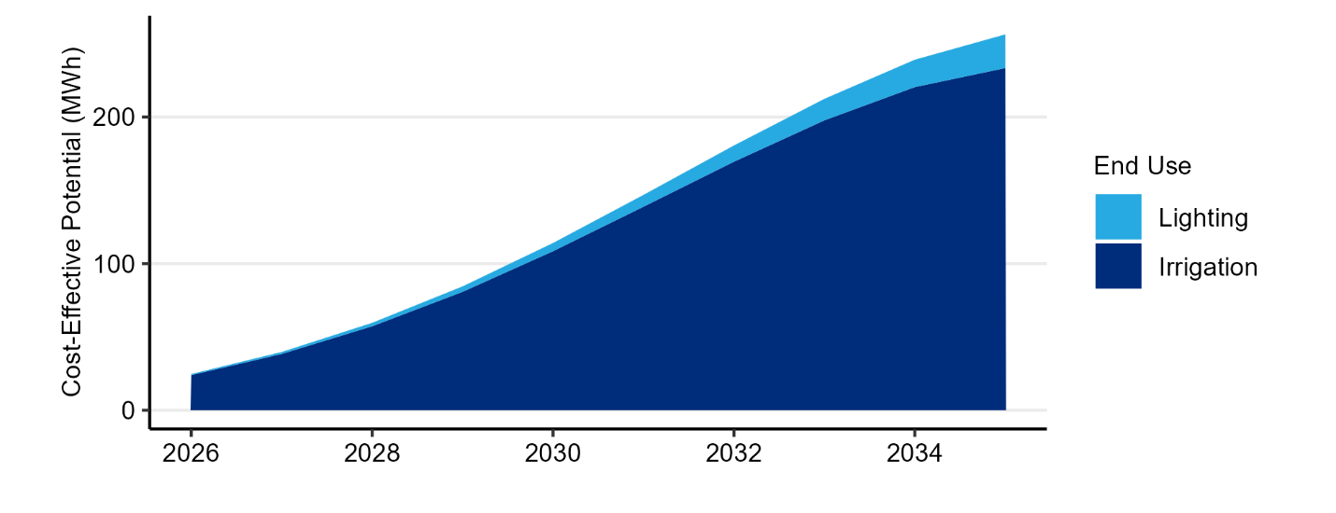

The breakdown of 10-year agricultural potential into end uses and measure categories is shown in Figure 24.

Figure : Agricultural Potential by End Use and Measure Category

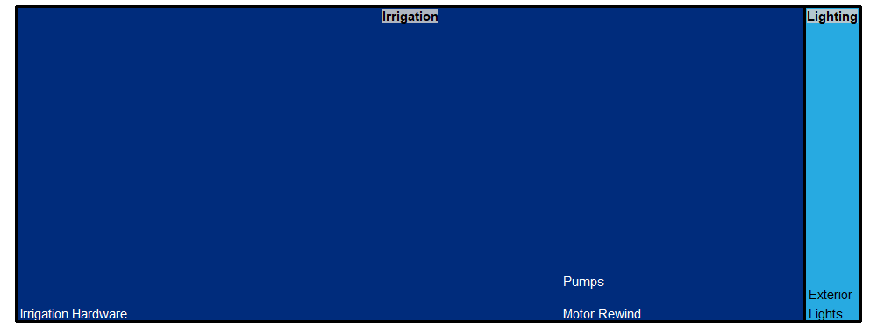

# Sensitivity Results

This section discusses the results of two sensitivity analyses that were evaluated in addition to the base case results described in the preceding sections. These sensitivities examined low and high variations of the avoided costs values to provide a range of possible outcomes given the uncertainty inherent in estimating these costs over a 20-year period. This allows Inland Power to understand how the cost-effective potential varies with changes in the avoided cost. All other inputs were held constant.

Table 10 summarizes the avoided cost assumptions used in each sensitivity, which are discussed further in Appendix IV.

Table 10: Avoided Cost Assumptions by Sensitivity

|  |  |  |  |  |
| --- | --- | --- | --- | --- |
|  |  | **Low Sensitivity** | **Base Case** | **High Sensitivity** |
| **Energy Values** | **Avoided Energy Costs**  **(20-Year Levelized Price, 2016$/MWh)** | Market Forecast minus 20%-80%  ($19) | Market Forecast  ($35) | Market Forecast plus 20%-80%  ($50) |
| **Social Cost CO2** | Federal 2.5% Discount Rate Values | Federal 2.5% Discount Rate Values | Federal 2.5% Discount Rate Values |
| **RPS Compliance** | WA EIA & CETA Requirements | WA EIA & CETA Requirements | WA EIA & CETA Requirements |
| **Capacity Values** | **Distribution Capacity**  **(2016$)** | $7.82/kW-year | $7.82/kW-year | $7.82/kW-year |
| **Transmission Capacity**  **(2016$)** | $3.54/kW-year | $3.54/kW-year | $3.54/kW-year |
| **Generation Capacity**  **(2016$)** | $65/kW-year | $75/kW-year | $123/kW-year |
|  | **Implied Risk Adder**  **(2016$)** | -$16/MWh  -$10/kW-year | N/A | $15/MWh  $48/kW-year |
|  | **NW Power Act Credit** | 10% | 10% | 10% |

Instead of using a single risk adder applied to each unit of energy, these two sensitivities consider potential futures with higher and lower values for the avoided cost inputs with larger degrees of uncertainty: the value of avoided energy and generation capacity.

Table 11 summarizes the variation in cost-effective potential across each avoided cost sensitivity. The low sensitivity results in almost 13,000 less MWh of cost-effective savings, while the high sensitivity results in an additional 9,632 MWh of cost-effective savings.

Table 11: Cost Effective Potential (MWh) by Avoided Cost Sensitivity

|  |  |  |  |  |
| --- | --- | --- | --- | --- |
| **Sensitivity** | **2-Year** | **4-Year** | **10-Year** | **20-Year** |
| Low Sensitivity | 2,435 | 7,833 | 54,211 | 177,156 |
| Base Case | 2,741 | 8,799 | 59,313 | 189,961 |
| High Sensitivity | 3,211 | 9,964 | 63,354 | 199,593 |

# Summary

This report summarized the results of the 2025 CPA conducted for Inland Power. The assessment provided estimates of the cost-effective energy savings potential for the 20-year period beginning in 2026, with detail on the first two and ten years per the requirements of Washington State’s EIA. The assessment considered a wide range of measures that are reliable and available during the study period.

Compared to Inland Power’s 2023 CPA, the cost-effective potential has decreased. The decreases in cost-effective potential are driven by updated customer forecasts, lower avoided costs, updated measure assumptions, incorporation of the state’s mercury lighting ban, and adjustments to account for Inland Power’s recent achievements.

## Compliance with State Requirements

The methodology used to estimate the cost-effective energy efficiency potential described in this report is consistent with the methodology used by the Council in determining the potential and cost-effectiveness of conservation resources in the 2021 Power Plan. Appendix III provides a list of Washington’s EIA requirements and a description of how each was implemented. In addition to using a methodology consistent with the Council’s 2021 Power Plan, the assessment used assumptions from the 2021 Power Plan where utility-specific inputs were not used. Utility-specific inputs covering customer characteristics, previous conservation achievements, and some economic inputs were used. The assessment included the measures considered in the 2021 Power Plan materials, updated with new information from the RTF made available since its publication.

# References

Evergreen Economics. (2024). 2022 Residential Building Stock Assessment. Portland, OR: Northwest Energy Efficiency Alliance. <https://neea.org/data/residential-building-stock-assessment>

Cadmus Group. (2020). Commercial Building Stock Assessment 4 (2019) Final Report. Portland, OR: Northwest Energy Efficiency Alliance. <https://neea.org/data/commercial-building-stock-assessments>

Northwest Power and Conservation Council. (December 11, 2020). 2021 Power Plan Technical Information and Data. <https://www.nwcouncil.org/2021-power-plan-technical-information-and-data>

Oak Ridge National Laboratory. (1987). Electricity Use and Savings in the Hood River Conservation Project. <https://www.osti.gov/biblio/6880640>

Regional Technical Forum. Unit Energy Savings Measures Library. <https://rtf.nwcouncil.org/measures/>

Regional Technical Forum. (2023). Regional Conservation Progress Report. <https://rtf.nwcouncil.org/about-rtf/conservation-achievements/2023/>

Northwest Power and Conservation Council. (1980). Pacific Northwest Electric Power Planning and Conservation Act. <https://www.nwcouncil.org/reports/northwest-power-act/>

US Census Bureau. American Community Survey. <https://www.census.gov/programs-surveys/acs>

# Appendix I: Acronyms

aMW Average Megawatt

BPA Bonneville Power Administration

CETA Clean Energy Transformation Act

CPA Conservation Potential Assessment

EIA Energy Independence Act

EUI Energy Use Intensity

HPWH Heat Pump Water Heater

HVAC Heating, Ventilation, and Air Conditioning

kW kilowatt

kWh kilowatt-hour

LED Light-Emitting Diode

MW Megawatt

MWh Megawatt-hour

NEEA Northwest Energy Efficiency Alliance

O&M Operations and Maintenance

RPS Renewable Portfolio Standard

RTF Regional Technical Forum

SEM Strategic Energy Management

TRC Total Resource Cost

# Appendix II: Glossary

|  |  |
| --- | --- |
| *Achievable Technical Potential* | Conservation potential that includes considerations of market barriers and programmatic constraints but not cost effectiveness. This is a subset of technical potential. |
| *Average Megawatt (aMW)* | An average hourly usage of electricity, measured in megawatts, across the hours of a day, month, or year |
| *Avoided Cost* | The costs avoided through the acquisition of energy efficiency |
| *Cost Effective* | A measure is described as cost effective when the present value of its benefits exceeds the present value of its costs |
| *Economic Potential* | Conservation potential that passes a cost-effectiveness test. This is a subset of achievable potential. Per the EIA, a Total Resource Cost (TRC) test is used. |
| *Levelized Cost* | A measure of costs when they are spread over the life of the measure, similar to a car payment. Levelized costs enable the comparison of resources with different useful lifetimes. |
| *Megawatt (MW)* | A unity of demand equal to 1,000 kilowatts (kW) |
| *Renewable Portfolio Standard* | A requirement that a certain percentage of a utility’s portfolio come from renewable resources. In 2020, Washington utilities with more than 25,000 customers are required to source 15% of their energy from renewable resources |
| *Technical Potential* | The set of possible conservation savings that includes all possible measures, regardless of market or cost barriers |
| *Total Resource Cost (TRC) Test* | A test for cost-effectiveness that considers all costs and benefits, regardless of who they accrue to. A measure passes this test if the present value of all benefits exceeds the present value of all costs. The TRC test is required by Washington’s Energy Independence act and is the predominant cost effectiveness test used throughout the Northwest and US. |

# Appendix III: Compliance with State Requirements

This Appendix details the specific requirements for Conservation Potential Assessments listed in WAC 194-37-070. The table below lists the specific section and corresponding requirement along with a description of how the requirement is implemented in the model and where the implementation can be found.

Table : CPA Compliance

| **WAC**  **194-37-070**  **Section** | **Requirement** | **Implementation** |
| --- | --- | --- |
| (5)(a) | **Technical potential.** Determine the amount of conservation that is technically feasible, considering measures and the number of these measures that could physically be installed or implemented, without regard to achievability or cost. | The model calculates technical potential by multiplying the quantity of stock (number of homes, building floor area, industrial load) by the measure savings that could be installed per each unit of stock. The model further constrains the potential by the share of measures that have already been completed.  See calculations in the “Units” tabs within each of the sector model files. |
| (5)(b) | **Achievable technical potential**. Determine the amount of the conservation technical potential that is available within the planning period, considering barriers to market penetration and the rate at which savings could be acquired. | The model applies maximum achievability factors based on the Council’s 2021 Power Plan assumptions and ramp rates to identify how the potential can be acquired over the study period.  See calculations in the “Units” tabs within each of the sector model files. The complete set of the ramp rates used is on the “Ramp Rates” tab. |
| (5)(c) | **Economic achievable potential**. Establish the economic achievable potential, which is the conservation potential that is cost-effective, reliable, and feasible, by comparing the total resource cost of conservation measures to the cost of other resources available to meet expected demand for electricity and capacity. | The project team used the benefit-cost ratio approach described in (5)(c)(ii), using the Council’s ProCost model to calculate TRC benefit-cost ratios for each measure after updating ProCost with utility-specific inputs. The ProCost results are collected through an Excel macro in the “ProCost Measure Results-[sensitivity name].xlsx” files and brought into the CPA models through Excel’s Power Query.  See Appendix IV for further discussion of the avoided cost assumptions. |
| (5)(d) | **Total resource cost**. In determining economic achievable potential as provided in (c) of this subsection, perform a life-cycle cost analysis of measures or programs to determine the net levelized cost, as described in this subsection: | A life-cycle cost analysis was performed using the Council’s ProCost tool, which the project team configured with utility-specific inputs. Costs and benefits were included consistent with the TRC test.  The measure files within each sector contain the ProCost results. These results are then rolled up into the ProCost Measure Results file, which is linked to each sector model file. |
| (5)(d)(i) | Conduct a total resource cost analysis that assesses all costs and all benefits of conservation measures regardless of who pays the costs or receives the benefits; | The costs considered in the levelized cost include measure capital costs, O&M costs, periodic replacement costs, and any non-energy costs. Benefits included avoided energy, T&D capacity costs, avoided generation capacity costs, non-energy benefits, O&M savings, periodic replacement costs.  Measure costs and benefits can be found in the individual measure files as well as the “ProCost Measure Results” file. |
| (5)(d)(ii) | Include the incremental savings and incremental costs of measures and replacement measures where resources or measures have different measure lifetimes; | Assumed savings, cost, and measure lifetimes are based on 2021 Power Plan and subsequent RTF updates, where applicable.  Measure costs and benefits can be found in the individual measure files as well as the “ProCost Measure Results” files. |
| (5)(d)(iii) | Calculate the value of the energy saved based on when it is saved. In performing this calculation, use time differentiated avoided costs to conduct the analysis that determines the financial value of energy saved through conservation | The project team used a 20-year forecast of monthly on- and off-peak market prices and the load shapes developed for the 2021 Power Plan as part of the economic analysis conducted in ProCost.  “MC and Loadshape” files contain both the market price forecast and the library of load shapes. Individual measure files contain the load profile assignments. |
| (5)(d)(iv) | Include the increase or decrease in annual or periodic operations and maintenance costs due to conservation measures | Measure analyses include changes to O&M costs as well as periodic replacement costs, where applicable.  Measure assumptions can be found in the individual measure files. |
| (5)(d)(v) | Include avoided energy costs equal to a forecast of regional market prices, which represents the cost of the next increment of available and reliable power supply available to the utility for the life of the energy efficiency measures to which it is compared | The project team incorporated a 20-year forecast of on- and off-peak market prices at the mid-Columbia trading hub based on available forward prices. Further discussion of this forecast can be found in Appendix IV.  See the “MC and Loadshape” file for the market prices. These prices include the value of avoided REC purchases as applicable. |
| (5)(d)(vi) | Include deferred capacity expansion benefits for transmission and distribution systems | Deferred transmission and distribution system benefits are based on the values developed by the Council for the 2021 Power Plan.  These values can be found on the “ProData” tab of the ProCost files, cells C50 and C54. |
| (5)(d)(vii) | Include deferred generation benefits consistent with the contribution to system peak capacity of the conservation measure | Deferred generation capacity expansion benefits are based on monthly demand costs, which represents the utility cost of capacity. The development of these values is discussed in Appendix IV.  These values can be found on the “ProData” tab of the ProCost files, cells C60. |
| (5)(d)(viii) | Include the social cost of carbon emissions from avoided non-conservation resources | This assessment uses the social cost of carbon values determined by the federal Interagency Workgroup using a 2.5% discount rate, as required by the Clean Energy Transformation Act.  The carbon costs can be found in the MC and Loadshape file. |
| (5)(d)(ix) | Include a risk mitigation credit to reflect the additional value of conservation, not otherwise accounted for in other inputs, in reducing risk associated with costs of avoided non-conservation resources | This analysis uses a sensitivity analysis to consider risk. Avoided cost values with uncertain future values were varied across three different sensitivity and the resulting variation and risk were analyzed.  The Sensitivity Results section of this report discusses the inputs used and the implicit risk adders used in the analysis. |
| (5)(d)(x) | Include all non-energy impacts that a resource or measure may provide that can be quantified and monetized | All quantifiable non-energy benefits were included where appropriate, based on values from the Council’s 2021 Power Plan materials and updates from the RTF.  Measure assumptions can be found in the individual measure files. |
| (5)(d)(xi) | Include an estimate of program administrative costs | This assessment uses the Council’s assumption of administrative costs equal to 20% of measure capital costs.  Program admin costs can be found in the “ProData” tab of the ProCost file, cell C29. |
| (5)(d)(xii) | Include the cost of financing measures using the capital costs of the entity that is expected to pay for the measure | This assessment utilizes the financing cost assumptions from the 2021 Power Plan materials, including the sector-specific cost shares and cost of capital assumptions.  Financing assumptions can be found in the ProData tab of the ProCost batch runner files, cells C37:F46. |
| (5)(d)(xiii) | Discount future costs and benefits at a discount rate equal to the discount rate used by the utility in evaluating non-conservation resources | This assessment uses a real discount rate of 3.75% to determine the present value of all costs and benefits. This represents the utility’s long-term cost of capital.  The discount rate used in this analysis can be found in the ProCost file, on cell C27 of the ProData tab. |
| (5)(d)(xiv) | Include a ten percent bonus for the energy and capacity benefits of conservation measures as defined in 16 U.S.C. § 839a of the Pacific Northwest Electric Power Planning and Conservation Act | A 10% bonus is applied consistent with the NW Power Act.  The 10% credit used in the measure analyses can be found in the ProCost files, on cell C29 of the ProData tab. |

# Appendix IV: Avoided Costs

The methodology used to conduct conservation potential assessments for electric utilities in the State of Washington is dictated by the requirements of the Energy Independence Act (EIA) and the Clean Energy Transformation Act (CETA). Specifically, WAC 194-37-070 requires utilities to determine the economic, or cost-effective, potential by “comparing the total resource cost of conservation measures to the total cost of other resources available to meet expected demand for electricity and capacity.”[8] The CPA will determine the cost-effectiveness of conservation measures through a benefit-cost ratio approach, which uses the avoided costs of energy efficiency to represent the costs avoided by acquiring efficiency instead of other resources. The EIA specifies that these avoided costs applied to energy efficiency measures include the following components:

* Time-differentiated energy costs equal to a forecast of regional market prices
* Deferred capacity expansion costs for the transmission and distribution system
* Deferred generation capacity costs consistent with each measure’s contribution to system peak capacity savings
* The social cost of carbon emissions from avoided non-conservation resources
* A risk mitigation credit to reflect the additional value of conservation not accounted for in other inputs
* A 10% bonus for energy and capacity benefits of conservation measures, as defined by the Pacific Northwest Electric Power Planning and Conservation Act

In addition to these requirements, Washington’s CETA requires the use of specific values for the social cost of carbon.[9] The project team has also included the value of avoided renewable portfolio standard compliance costs as energy efficiency can reduce these costs.

The CETA requirements for demand response potential assessments are less specific but do clarify that utilities must assess potential for demand response that is “cost-effective, reliable, and feasible”[10], and targets should be consistent with the utility’s resource plan for distributed resources (such as energy efficiency). Therefore, the project team relied on the same avoided cost inputs for the DRPA as the CPA when the values were applicable.

This appendix discusses each of these inputs in detail in the following sections.

## Avoided Energy Costs

Avoided energy costs are the energy costs avoided by Inland Power through the acquisition of energy efficiency instead of supply-side resources. For every megawatt-hour of conservation achieved, Inland Power can avoid the purchase of one megawatt-hour of energy or sell one additional megawatt-hour of excess energy.

For this CPA, Inland Power provided a forecast of monthly on- and off-peak energy prices at the Mid-Columbia trading hub. The forecast was prepared on July 7, 2025, and the prices cover a period extending to December of 2033.

To benchmark these prices, the project team compared them to monthly on- and off-peak price futures for the Mid-Columbia trading hub reported by the Intercontinental Exchange on July 17, 2025. Comparisons of the two sources are shown in Figure 25 and Figure 26. While there are some small differences, overall, the prices are quite similar. The small differences are expected based on the difference in the date on which the forecasts were prepared.

Figure : Benchmarking of On-Peak Prices

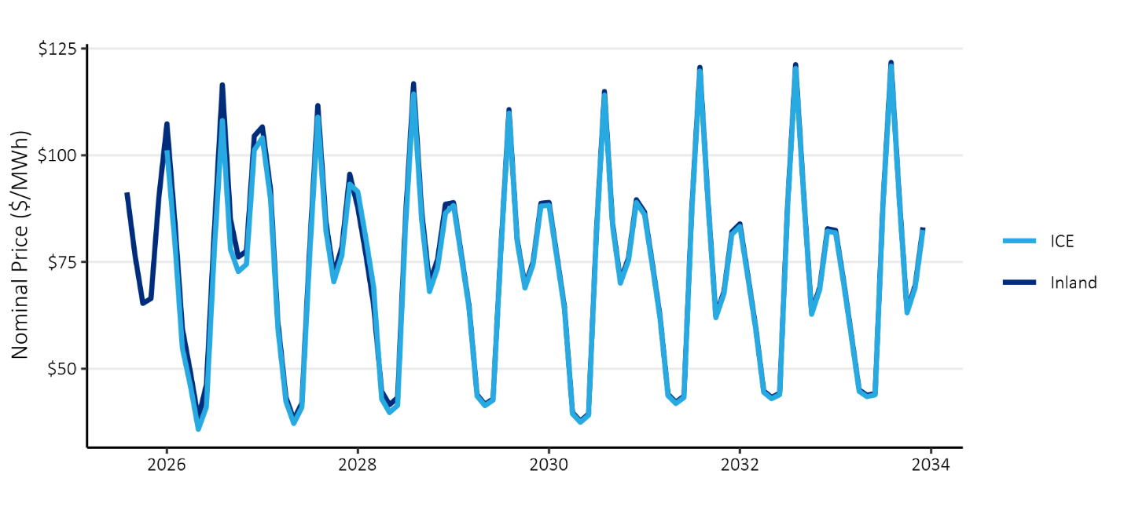

Figure : Benchmarking of Off-Peak Prices

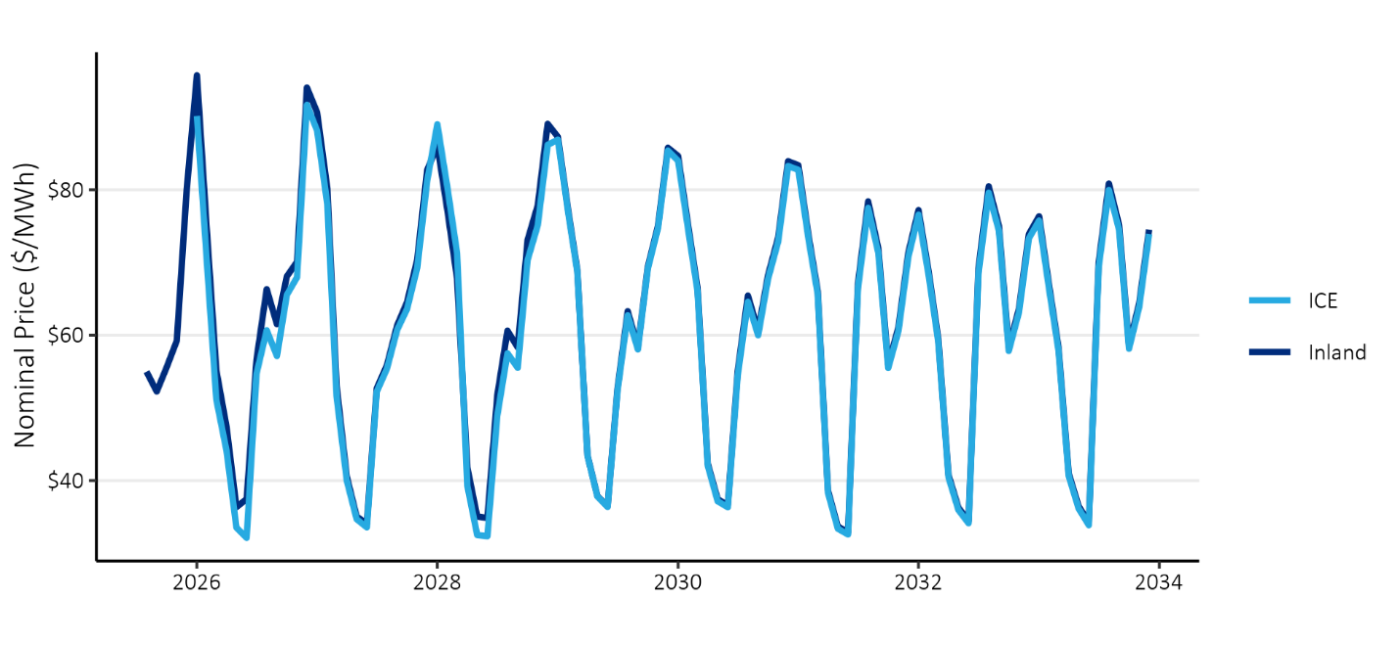

To develop a forecast that covers the full 20-year study period of this CPA, the project team extended the Inland Power forecast through 2045. After reviewing market price forecasts from other utilities, including Puget Sound Energy[11], Pacific Power[12], and the market prices used for energy efficiency in Oregon[13], the project team extended the forecast by extending the values from 2033. Figure 27 shows the resulting on- and off-peak prices resulting from this process.

Figure : On- and Off-Peak Price Forecast

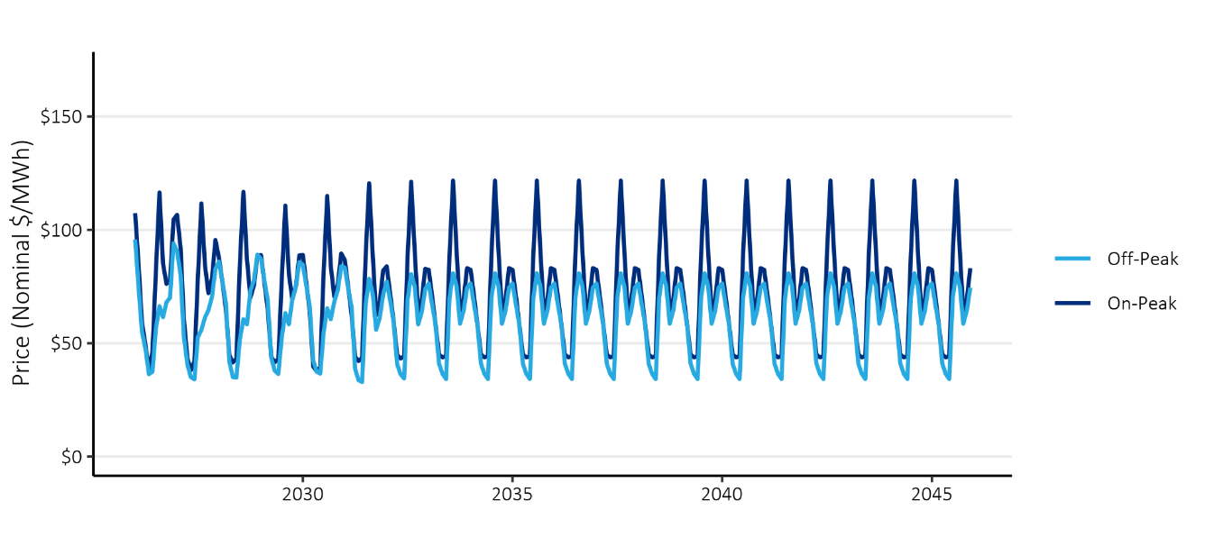

These values will ultimately be converted to 2016 dollars for consistency with the measure cost assumptions used in the 2021 Power Plan, which are also expressed in 2016 dollars. The levelized value of the 20-year price forecast is $35/MWh (2016$), a decrease from the $52/MWh levelized value from Inland Power’s 2023 CPA.

The project team also created high and low variations of this forecast to be used in a sensitivity analysis, since the actual future values of these prices are uncertain. To develop the forecast, the project team assumed that the high and low prices would vary by approximately 20% in the near term and 80% in the long term, relative to the base case price forecast. A similar approach was used in Inland Power’s prior CPA, which was based on the variation observed in price forecasts in the 2021 Power Plan. The project team applied this variation to the forecast described above to create high and low forecasts. The resulting forecasts for on- and off-peak prices are shown in

Figure 28 and Figure 29 below.

Figure : Comparison of On-Peak Price Sensitivities

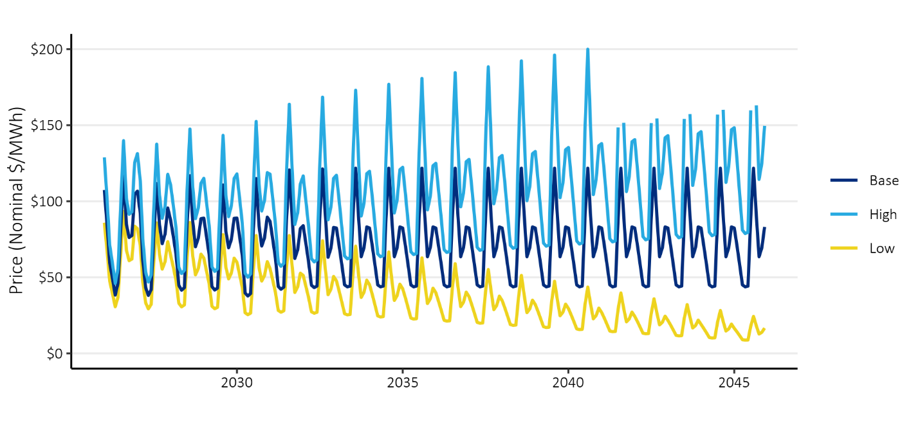

Figure : Comparison of Off-Peak Price Sensitivities

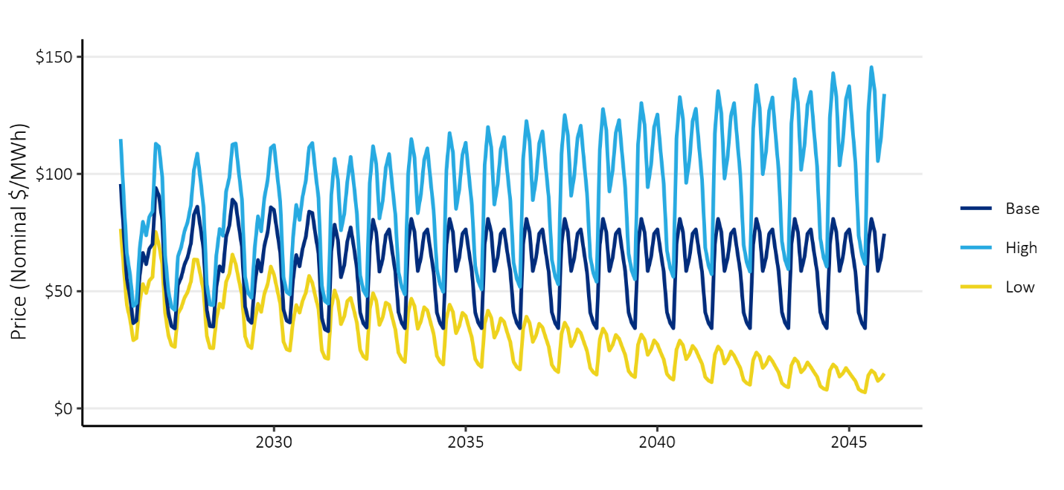

## Deferred Transmission and Distribution Capacity Costs

Unlike supply-side resources, energy efficiency and demand response do not require transmission and distribution infrastructure. Instead, these resources free up capacity in the transmission and distributions systems by reducing the peak demands and, over time, can help defer or avoid future capacity expansions and the associated capital costs.

In the development of the 2021 Power Plan, the Council developed a standardized methodology and surveyed the region to calculate these values. This CPA and DRPA use the values developed by the Council through that process: $3.54 and $7.82 per kW-year (2016$) for transmission and distribution capacity, respectively. These values were used in Inland Power’s 2023 CPA. While the Council has prepared draft updates to these values as part of the 9th Power Plan, Inland Power is electing to continue using the 2021 Plan values until the 9th plan values are finalized, or additional Inland Power specific data can be used to inform this assumption.

These values are applied to energy efficiency and demand response measures based on each measure’s reduction in demand that is coincident with the timing of the transmission and distribution system peaks.

## Deferred Generation Capacity Costs

Similar to the transmission and distribution systems discussed above, acquiring energy efficiency and demand response resources can also defer or eliminate the costs of new generation resources needed to meet peak demands for electricity.

In the CPA, the project team followed a similar methodology to what was used in Inland Power’s previous CPAs. The project team used BPA’s monthly demand charges as proxy costs for the value of capacity and converted the monthly demand charges to an annual generation capacity value using assumptions about energy efficiency capacity contributions by month.

In the base case, the project team assumed that these demand charges would increase by 1.6% each year, consistent with the growth rate observed in recent years, and calculated a 20-year series of annual generation capacity values which were then levelized to calculate the single value that is required for the Council’s ProCost model. This resulted in a base case value of $75/kW-year (2016$), a decrease from the $76/kW-year used in the 2023 CPA. For the low case, no price escalation was assumed, resulting in a value of $65/kW-year. In the high case, the project team used Council’s 2021 Power Plan value, which is $123/kW-year. This value reflects the levelized cost of capacity for a battery storage system and includes expected future cost decreases.

In the DRPA, BPA’s monthly values for generation capacity were used directly and applied during the months in which demand response events were likely to be called.

## Social Cost of Carbon

In addition to avoiding purchases of energy and capacity, energy efficiency measures can avoid emissions of greenhouse gases like carbon dioxide. Washington’s EIA requires that CPAs include the social cost of carbon, which the US EPA defines as a measure of the long-term damage done by a ton of carbon dioxide emissions in a given year. The EPA describes it as including, among other things, changes in agricultural productivity, human health, property damage from increased flood risk, and changes in energy system costs, including increases in the costs of cooling and decreases in heating costs.[14] In addition to this requirement, Washington’s CETA requires that utilities use the social cost of carbon values developed by the federal Interagency workgroup using a 2.5% discount rate. These values are used in all avoided cost sensitivities of the CPA.

To implement the cost of carbon emissions, additional assumptions must be made about the intensity of carbon emissions per unit of energy. This assessment uses an updated forecast of marginal emissions rates developed by the Council in 2024.[15] The average annual values from this analysis are shown in Figure 30 below. The values start near 1, which is approximately the emissions rate from natural gas turbines and declines over time as the generation resource pool shifts to clean resources over time.

Figure : Council Marginal Emissions Rate Forecast

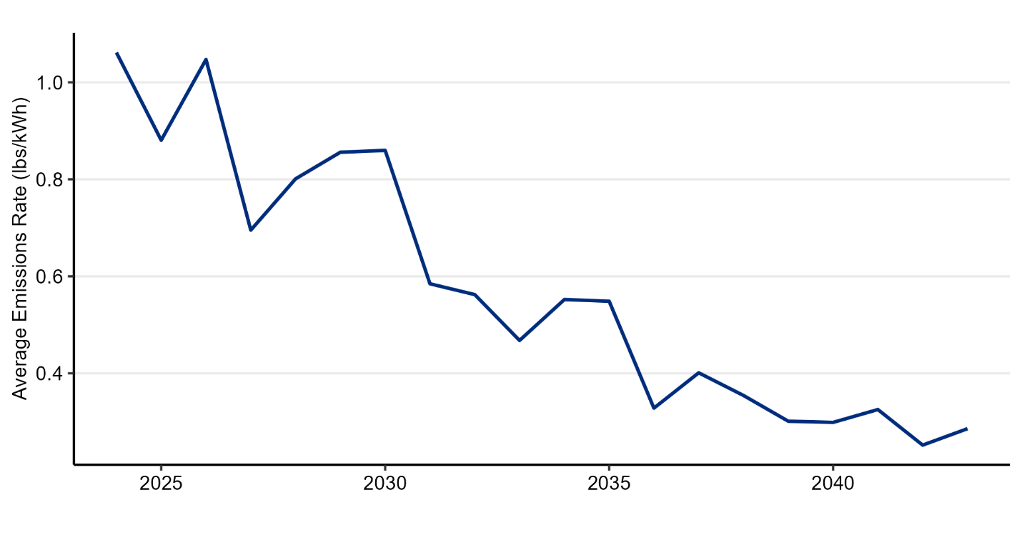

## Renewable Portfolio Standard Compliance Costs

The renewable portfolio standard established under Washington’s EIA requires that Inland Power source 15% of retail sales from renewable resources. The subsequently passed CETA furthers these requirements, mandating that 100% of sales be greenhouse gas neutral in 2030, with an allowance that up to 20% of the requirement can be achieved through other options, such as the purchase of Renewable Energy Credits (RECs).

Energy efficiency can reduce the cost of complying with these requirements by reducing Inland Power’s overall load. In 2026, a reduction in load of 100 MWh through energy efficiency would reduce the number of RECs required for compliance by 15. Therefore, one megawatt-hour of energy savings is equal to 15% of the cost of a REC. In 2030, it was assumed that marginal energy purchases would also include the purchase of a REC, thus the full price of a REC was added to the energy price after 2030. In 2045, the last year of the study period, CETA’s requirements change, and unbundled RECs are no longer allowed for compliance. However, the combination of market prices and RECs represents a reasonable proxy for clean energy resources.

The project team developed a forecast of REC prices based on input from several Washington utility clients.

## Risk Mitigation Credit

Any purchase of a resource involves risk. The decision to invest is based on uncertain forecasts of loads and market conditions. Investing in energy efficiency can reduce the risks that utilities face by the fact that it is made in small increments over time, rather than the large, singular sums required for generation resources. A decision not to invest in energy efficiency could result in exposure to higher market prices than forecast, an unneeded infrastructure investment, or one that cannot economically dispatch due to low market prices. While over-investments in energy efficiency are possible, the small and discrete amounts invested in energy efficiency limit the scale of any exposure to this risk.

In its power planning work, the Council develops a risk mitigation credit to account for this risk. This credit accounts for the value of energy efficiency not explicitly included in the other avoided cost values, ensuring that the level of cost-effective energy efficiency is consistent with the outcomes of the power planning process. The credit is determined by identifying the value that results in a level of cost-effective energy efficiency potential that is equivalent to the regional targets set by the Council.

In the 2021 Power Plan, the Council determined that no risk credit was necessary after including carbon costs and a generation capacity value in its avoided cost.

This CPA follows the process used in Inland Power’s previous CPAs and is similar to the process followed by the Council. A sensitivity analysis is used to account for uncertainty in the avoided cost values applied to energy efficiency measures, where present. The variation in energy and capacity values covers a range of possible outcomes and the sensitivity of the cost-effective energy efficiency potential is identified by comparing the outcomes of each sensitivity. In selecting its biennial target based on this range of outcomes, Inland Power is selecting its preferred risk strategy and the associated risk credit.

## Northwest Power Act Credit

Finally, this CPA includes a 10% cost credit for energy efficiency. This credit is specified in the Pacific Northwest Electric Power Planning and Conservation Act for regional power planning work completed by the Council and by Washington’s EIA for CPAs completed for Washington utilities. This credit is applied as a 10% bonus to the energy and capacity benefits described above.

## Summary

Table 13 summarizes the energy efficiency avoided cost assumptions used in each of the sensitivities in this CPA update.

Table : Energy Efficiency Avoided Cost Assumptions by Sensitivity

|  |  |  |  |  |
| --- | --- | --- | --- | --- |
|  |  | **Low Sensitivity** | **Base Case** | **High Sensitivity** |
| **Energy Values** | **Avoided Energy Costs**  **(20-Year Levelized Price, 2016$/MWh)** | Market Forecast minus 20%-80%  ($19) | Market Forecast  ($35) | Market Forecast plus 20%-80%  ($50) |
| **Social Cost CO2** | Federal 2.5% Discount Rate Values | Federal 2.5% Discount Rate Values | Federal 2.5% Discount Rate Values |
| **RPS Compliance** | WA EIA & CETA Requirements | WA EIA & CETA Requirements | WA EIA & CETA Requirements |
| **Capacity Values** | **Distribution Capacity**  **(2016$)** | $7.82/kW-year | $7.82/kW-year | $7.82/kW-year |
| **Transmission Capacity**  **(2016$)** | $3.54/kW-year | $3.54/kW-year | $3.54/kW-year |
| **Generation Capacity**  **(2016$)** | $65/kW-year | $75/kW-year | $123/kW-year |
|  | **Implied Risk Adder**  **(2016$)** | -$16/MWh  -$10/kW-year | N/A | $15/MWh  $48/kW-year |
|  | **NW Power Act Credit** | 10% | 10% | 10% |

# Appendix V: Measure List

This appendix provides a list of the measures that were included in this assessment and the data sources that were used for any measure characteristics. The assessment used all measures from the 2021 Power Plan that were applicable to Inland Power. The project team customized these measures to make them specific to Inland Power’s service territory and updated many with new information available from the Regional Technical Forum. The RTF continually updates estimates of measure savings and cost. This assessment used the most up to date information available when the CPA was developed.

This list is high-level and does not reflect the thousands of variations for each individual measure. Instead, it summarizes measures by category. Many measures include variations specific to different home or building types, efficiency level, or other characterization. For example, attic insulation measures are differentiated by home type (e.g., single family, multifamily, manufactured home), heating system (e.g., heat pump or furnace), baseline insulation level (e.g., R0, R11, etc.) and maximum insulation possible (e.g., R22, R30, R38, R49). This differentiation allows for savings and cost estimates to be more precise.

The measure list is grouped by sector and end use. Note that all measures may not be applicable to an individual utility service territory based on the characteristics of individual utilities and their customer sectors.

Table : Residential End Uses and Measures

|  |  |  |
| --- | --- | --- |
| **End Use** | **Measure Category** | **Data Source(s)** |
| Appliances | Air Cleaner | 2021 Power Plan, RTF |
|  | Clothes Washer | 2021 Power Plan, RTF |
|  | Clothes Dryer | 2021 Power Plan, RTF |
|  | Freezer | 2021 Power Plan, RTF |
|  | Refrigerator | 2021 Power Plan, RTF |
| Cooking | Electric Oven | 2021 Power Plan |
| Microwave | 2021 Power Plan |
| Electronics | Advanced Power Strips | 2021 Power Plan, RTF |
|  | Desktop | 2021 Power Plan |
|  | Laptop | 2021 Power Plan |
|  | Monitor | 2021 Power Plan |
|  | TV | 2021 Power Plan |
| EVSE | EVSE | 2021 Power Plan |
| HVAC | Air Source Heat Pump | 2021 Power Plan, RTF |
|  | Central Air Conditioner | 2021 Power Plan, RTF |
|  | Cellular Shades | 2021 Power Plan |
|  | Circulator | 2021 Power Plan |
|  | Circulator Controls | 2021 Power Plan |
|  | Ductless Heat Pump | 2021 Power Plan, RTF |
|  | Duct Sealing | 2021 Power Plan, RTF |
|  | Ground Source Heat Pump | 2021 Power Plan |
|  | Heat Recovery Ventilator | 2021 Power Plan |
|  | Room Air Conditioner | 2021 Power Plan |
|  | Smart Thermostats | 2021 Power Plan, RTF |
|  | Weatherization | 2021 Power Plan, RTF |
|  | Whole House Fan | 2021 Power Plan |
| Lighting | Fixtures | 2021 Power Plan, RTF |
|  | Lamps | 2021 Power Plan, RTF |
|  | Pin Lamps | 2021 Power Plan, RTF |
| Motors | Well Pump | 2021 Power Plan |
| Water Heat | Aerators | 2021 Power Plan, RTF |
|  | Circulator | 2021 Power Plan |
|  | Circulator Controls | 2021 Power Plan |
|  | Dishwasher | 2021 Power Plan |
|  | Gravity Film Heat Exchanger | 2021 Power Plan |
|  | Heat Pump Water Heater | 2021 Power Plan, RTF |
|  | Pipe Insulation | 2021 Power Plan |
|  | Showerhead | 2021 Power Plan |
|  | Thermostatic Restrictor Valve | 2021 Power Plan, RTF |
| Whole Home | Behavior | 2021 Power Plan |

Table : Commercial End Uses and Measures

|  |  |  |
| --- | --- | --- |
| **End Use** | **Measure Category** | **Data Source(s)** |
| Compressed Air | Air Compressor | 2021 Power Plan |
| Electronics | Computers | 2021 Power Plan |
| Power Supplies | 2021 Power Plan |
| Smart Power Strips | 2021 Power Plan, RTF |
| Servers | 2021 Power Plan |
| Food Preparation | Combination Ovens | 2021 Power Plan, RTF |
| Convection Ovens | 2021 Power Plan, RTF |
| Fryers | 2021 Power Plan, RTF |
| Griddle | 2021 Power Plan, RTF |
| Hot Food Holding Cabinet | 2021 Power Plan, RTF |
| Overwrapper | 2021 Power Plan, RTF |
| Steamer | 2021 Power Plan, RTF |
| HVAC | Advanced Rooftop Controller | 2021 Power Plan, RTF |
| Chiller | 2021 Power Plan |
| Circulation Pumps | 2021 Power Plan, RTF |
| Ductless Heat Pump | 2021 Power Plan, DHP |
| Energy Management | 2021 Power Plan |
| Fans | 2021 Power Plan |
| Heat Pumps | 2021 Power Plan |
| Package Terminal Heat Pumps | 2021 Power Plan, RTF |
| Pumps | 2021 Power Plan, RTF |
| Smart Thermostats | 2021 Power Plan |
| Unitary Air Conditioners | 2021 Power Plan |
| Very High Efficiency Dedicated Outside Air System | 2021 Power Plan |
| Variable Refrigerant Flow Dedicated Outside Air System | 2021 Power Plan |
| Windows | 2021 Power Plan, RTF |
| Lighting | Exit Signs | 2021 Power Plan |
| Exterior Lighting | 2021 Power Plan |
| Garage Lighting | 2021 Power Plan |
| Interior Lighting | 2021 Power Plan |
| Stairwell Lighting | 2021 Power Plan |
| Streetlights | 2021 Power Plan |
| Motors & Drives | Pumps | 2021 Power Plan, RTF |
| Process Loads | Elevators | 2021 Power Plan |
|  | Engine Block Heater | 2021 Power Plan, RTF |
| Refrigeration | Freezer | 2021 Power Plan |
| Grocery Refrigeration | 2021 Power Plan, RTF |
| Ice Maker | 2021 Power Plan, RTF |
| Refrigerator | 2021 Power Plan, RTF |
| Vending Machine | 2021 Power Plan, RTF |
| Water Cooler Controls | 2021 Power Plan |
| Water Heating | Commercial Clothes Washer | 2021 Power Plan, RTF |
| Heat Pump Water Heater | 2021 Power Plan, RTF |
| Pre-Rinse Spray Valve | 2021 Power Plan, RTF |
| Pumps | 2021 Power Plan, RTF |
| Showerheads | 2021 Power Plan |

Table : Industrial End Uses and Measures

|  |  |  |
| --- | --- | --- |
| **End Use** | **Measure Category** | **Data Source(s)** |
| All Electric | Energy Management | 2021 Power Plan |
|  | Forklift Charger | 2021 Power Plan |
|  | Water/Wastewater | 2021 Power Plan |
| Compressed Air | Air Compressor | 2021 Power Plan |
|  | Air Compressors | 2021 Power Plan |
|  | Compressed Air Demand Reduction | 2021 Power Plan |
| Fans and Blowers | Fan Optimization | 2021 Power Plan |
|  | Fans | 2021 Power Plan, RTF |
| HVAC | HVAC | 2021 Power Plan |
| Lighting | High Bay Lighting | 2021 Power Plan |
|  | Lighting | 2021 Power Plan |
|  | Lighting Controls | 2021 Power Plan |
| Low Temp Refer | Motors | 2021 Power Plan |
|  | Refrigeration Retrofit | 2021 Power Plan |
| Material Handling | Motors | 2021 Power Plan |
|  | Paper | 2021 Power Plan |
|  | Wood Products | 2021 Power Plan |
| Material Processing | Hi-Tech | 2021 Power Plan |
|  | Motors | 2021 Power Plan |
|  | Paper | 2021 Power Plan |
|  | Pulp | 2021 Power Plan |
|  | Wood Products | 2021 Power Plan |
| Med Temp Refer | Food Storage | 2021 Power Plan |
|  | Motors | 2021 Power Plan |
|  | Refrigeration Retrofit | 2021 Power Plan |
| Melting and Casting | Metals | 2021 Power Plan |
| Other | Pulp | 2021 Power Plan |
| Other Motors | Motors | 2021 Power Plan |
| Pollution Control | Motors | 2021 Power Plan |
| Pumps | Pulp | 2021 Power Plan |
|  | Pump Optimization | 2021 Power Plan |
|  | Pumps | 2021 Power Plan, RTF |

Table : Utility Distribution End Uses and Measures

|  |  |  |
| --- | --- | --- |
| **End Use** | **Measure Category** | **Data Source** |
| Distribution | Line Drop Control with no Voltage/VAR Optimization | 2021 Power Plan |
| Line Drop Control with Voltage Optimization & AMI | 2021 Power Plan |

Table : Agricultural End Uses and Measures

|  |  |  |
| --- | --- | --- |
| **End Use** | **Measure Category** | **Data Source** |
| Irrigation | Irrigation Hardware | 2021 Power Plan, RTF |
| Motor Rewind | 2021 Power Plan, RTF |
| Pumps | 2021 Power Plan, RTF |
| Variable Rate Irrigation | 2021 Power Plan |
| Lighting | Dairy Lighting | 2021 Power Plan |
|  | Exterior Lights | 2021 Power Plan |
| Process Heating | Block Heater | 2021 Power Plan, RTF |
|  | Stock Tanks | 2021 Power Plan, RTF |
| Refrigeration | Dairy Refrigeration | 2021 Power Plan |
| Ventilation | Fans | 2021 Power Plan |

# Appendix VI: Cost-Effective Energy Efficiency Potential by End Use

Table : Cost-Effective Residential Potential by End Use (MWh)

|  |  |  |  |  |
| --- | --- | --- | --- | --- |
| **End Use** | **2-Year** | **4-Year** | **10-Year** | **20-Year** |
| Appliances | 523 | 1,497 | 8,530 | 34,924 |
| Cooking | 2 | 9 | 103 | 616 |
| Electronics | 24 | 93 | 1,215 | 4,103 |
| EVSE | - | - | - | - |
| HVAC | 816 | 2,620 | 14,982 | 35,893 |
| Lighting | 94 | 254 | 1,544 | 6,562 |
| Motors | - | - | - | - |
| Water Heat | 319 | 1,111 | 8,088 | 26,958 |
| Whole Home | - | - | - | - |
| **Total** | **1,779** | **5,584** | **34,462** | **109,057** |

Table : Cost-Effective Commercial Potential by End Use (MWh)

|  |  |  |  |  |
| --- | --- | --- | --- | --- |
| **End Use** | **2-Year** | **4-Year** | **10-Year** | **20-Year** |
| Compressed Air | 2 | 8 | 95 | 454 |
| Electronics | 52 | 212 | 1,932 | 2,719 |
| Food Preparation | 19 | 49 | 188 | 381 |
| HVAC | 54 | 227 | 2,762 | 13,439 |
| Lighting | 492 | 1,406 | 6,572 | 20,306 |
| Motors/Drives | 41 | 141 | 1,177 | 3,751 |
| Process Loads | - | - | - | - |
| Refrigeration | 54 | 223 | 2,739 | 10,828 |
| Water Heat | 4 | 17 | 202 | 1,083 |
| **Total** | **719** | **2,285** | **15,667** | **52,961** |

Table : Cost-Effective Industrial Potential by End Use (MWh)

|  |  |  |  |  |
| --- | --- | --- | --- | --- |
| **End Use** | **2-Year** | **4-Year** | **10-Year** | **20-Year** |
| All Electric | 18 | 75 | 907 | 2,989 |
| Compressed Air | 2 | 7 | 93 | 495 |
| Fans and Blowers | 2 | 9 | 145 | 919 |
| HVAC | 2 | 8 | 100 | 329 |
| Lighting | 30 | 104 | 848 | 1,979 |
| Low Temp Refrigeration | 0 | 1 | 15 | 73 |
| Material Handling | 0 | 1 | 10 | 81 |
| Material Processing | 0 | 1 | 21 | 163 |
| Med Temp Refrigeration | 5 | 20 | 247 | 909 |
| Melting and Casting | - | - | - | - |
| Other | - | - | - | - |
| Other Motors | 0 | 0 | 6 | 51 |
| Pollution Control | 0 | 0 | 1 | 7 |
| Pumps | 6 | 24 | 369 | 2,265 |
| **Total** | **64** | **250** | **2,763** | **10,258** |

Table : Cost-Effective Utility Distribution Efficiency by End Use (MWh)

|  |  |  |  |  |
| --- | --- | --- | --- | --- |
| **End Use** | **2-Year** | **4-Year** | **10-Year** | **20-Year** |
| LDC with no VVO | 23 | 93 | 999 | 2,941 |
| LDC with VVO & AMI | 92 | 378 | 4,064 | 11,966 |
| **Total** | **115** | **471** | **5,063** | **14,907** |

Table : Cost-Effective Agricultural Potential by End Use (MWh)

|  |  |  |  |  |
| --- | --- | --- | --- | --- |
| **End Use** | **2-Year** | **4-Year** | **10-Year** | **20-Year** |
| Irrigation | 62 | 200 | 1,268 | 2,305 |
| Lighting | 2 | 8 | 89 | 473 |
| Process Heating | - | - | - | - |
| Refrigeration | - | - | - | - |
| Ventilation | - | - | - | - |
| **Total** | **64** | **209** | **1,358** | **2,778** |

# Appendix VII: Ramp Rate Alignment Documentation

This section documents the application of ramp rates in Inland Power’s 2025 Conservation Potential Assessment (CPA), developed by Lighthouse Energy Consulting and Nauvoo Solutions (the study team). Ramp rates are annual values that approximate the portion of technical potential that can be realistically achieved in each year. For example, all unweatherized homes in Inland Power’s service territory could theoretically be weatherized in a single year. However, program budgets, workforce availability, and other dynamics make this impractical. As a result, only a portion of those homes could realistically be weatherized in a given year.

For equipment measures like clothes washers, upgrading to more efficient equipment is most likely to occur when the equipment reaches the end of its life and needs to be replaced. Therefore, ramp rates for equipment measures reflect the share of equipment turning over in a given year that is replaced with a more efficient model.

The ramp rates used in this study are based on those used in the 2021 Power Plan but were updated to reflect the fact that some time has elapsed since the 2021 Power Plan. The project team assigned ramp rates that align the near-term cost-effective potential quantified in the CPA with the recent and expected achievements of Inland Power’s energy efficiency programs. Under both CETA and EIA, utilities are required to pursue all conservation that is cost-effective, reliable, and achievable. Therefore, the ramp rates in this study are designed to ensure that the near-term potential is feasible and achievable for Inland Power’s programs and the measures considered for adoption meet regulatory cost-effectiveness criteria.

## Ramp Rate Alignment Process

Inland Power staff provided recent program achievement data, which the study team summarized by sector and end use. For the residential sector, the study team further classified program achievements by high-level measure categories.

Additionally, Inland Power benefits from the regional market transformation work of the Northwest Energy Efficiency Alliance (NEEA). To reflect this, the study team incorporated estimated energy efficiency savings from NEEA market transformation activity occurring in Inland Power’s service territory. These savings were allocated across sectors, end uses, and measure categories based on recent reporting of NEEA’s regional savings.

The study team compared the recent savings from Inland Power’s programs and NEEA’s market transformation initiatives with the initial estimates of the cost-effective energy efficiency potential identified in the CPA. The study team made changes to the assigned ramp rates to accelerate or decelerate the forecasted pace of savings acquisition to align future savings potential with recent programmatic achievements. Areas where there were little to no recent program achievements typically have a slow ramp rate applied to account for the fact that a program may need to build momentum over several years.

The following tables show how Inland Power’s recent programmatic achievements and allocated NEEA market transformation savings compare to the potential estimated to be cost-effective after adjusting the ramp rates. Color scaling has been applied to highlight the larger values. Discussion follows each table with additional detail.

### Residential

Table 24 shows how residential potential was aligned with recent achievements by measure category.

Note that ramp rate choices are discrete and may not provide exact alignment. The overall goal is to achieve a general alignment across end uses and measures.

Table 24: Alignment of Residential Program History and Potential by Measure Category (MWh)

|  |  |  |  |  |  |  |  |  |
| --- | --- | --- | --- | --- | --- | --- | --- | --- |
|  |  |  | **Program History** | | **CPA Cost-Effective Potential** | | | |
| **End Use** | **Category** | **2022** | **2023** | **2024** | **2026** | **2027** | **2028** | **2029** |
| Appliances | Clothes Washer | 132 | 152 | 152 | 118 | 163 | 204 | 241 |
| Appliances | Dryer | 56 | 66 | 66 | 34 | 67 | 115 | 185 |
| Appliances | Freezer | - | - | - | 4 | 7 | 12 | 20 |
| Appliances | Refrigerator | 75 | 88 | 86 | 56 | 75 | 91 | 106 |
| Cooking | Microwave | - | - | - | 1 | 1 | 2 | 4 |
| Cooking | Oven | - | - | - | 0 | 0 | 0 | 1 |
| Electronics | Advanced Power Strips | 87 | 0 | 0 | - | - | - | - |
| Electronics | Desktop | 10 | 12 | 12 | - | - | - | - |
| Electronics | Laptop | - | - | - | 1 | 2 | 3 | 5 |
| Electronics | TV | - | - | - | 7 | 14 | 24 | 38 |
| HVAC | ASHP | 252 | 149 | 106 | 69 | 112 | 164 | 228 |
| HVAC | CAC | - | - | - | 1 | 2 | 4 | 6 |
| HVAC | Circulator | - | - | - | 0 | 1 | 1 | 2 |
| HVAC | Circulator Controls | - | - | - | 0 | 0 | 0 | 0 |
| HVAC | DHP | 187 | 165 | 151 | - | - | - | - |
| HVAC | Duct Sealing | - | - | 29 | 30 | 49 | 75 | 108 |
| HVAC | GSHP | 7 | 34 | - | - | - | - | - |
| HVAC | Room AC | 1 | 1 | 1 | - | - | - | - |
| HVAC | Thermostat | 2,575 | 129 | 88 | 78 | 144 | 236 | 354 |
| HVAC | Weatherization | 205 | 205 | 186 | 135 | 195 | 270 | 355 |
| Lighting | Fixtures | - | - | - | 40 | 54 | 70 | 90 |
| Water Heat | Circulator | - | - | - | 0 | 0 | 1 | 1 |
| Water Heat | Circulator Controls | - | - | - | 0 | 1 | 1 | 2 |
| Water Heat | Dishwasher | - | - | - | 3 | 5 | 6 | 7 |
| Water Heat | HPWH | 161 | 141 | 151 | 100 | 185 | 289 | 425 |
| Water Heat | TSRV | - | - | - | 9 | 15 | 24 | 36 |
|  | **Total** | **3,748** | **1,142** | **1,027** | **686** | **1,093** | **1,592** | **2,213** |

*Note: For clarity, in the table above, measure categories with no program achievements and no cost-effective potential have been removed. In addition, note that some measures have savings values that are small and cannot be shown at this level of resolution. These values show as 0 in this and following tables while a true zero value is shown as a dash.*

The following sections discuss the alignment within each residential end use.

#### Appliances

In this end use, the savings are primarily from NEEA’s market transformation initiatives. NEEA’s work includes an initiative for retail products that includes appliances. The savings from this work typically grow over time as markets transform. Ramp rates were adjusted to align with the NEEA savings.

#### Cooking

Neither Inland Power nor NEEA have savings in this end use, so the measures—microwaves and ovens—were given slow ramp rates.

#### Electronics

The historical savings in this end use come from NEEA’s work advancing efficient desktop computers and a 2022 effort from Inland Power with advanced power strips. In the CPA, efficient Energy Star desktop computers were not cost-effective and therefore not incorporated in the future potential. The Regional Technical Forum (RTF) has recently deactivated advanced power strips due to a lack of data and confidence in the savings, so the measure was removed from this CPA. Going forward, the cost-effective potential is associated with TVs and laptops. The study team slowed the ramp rate for these categories since there are no current Inland Power programs or NEEA initiatives that would address these measures.

#### HVAC

Inland Power’s residential program savings for the past three years are primarily in the HVAC end use. More than 80% of the historical 2022 – 2024 savings are from Inland Power’s programs while the remainder are a result of NEEA’s market transformation in this area. Within Inland Power’s HVAC savings, the measures with the largest savings include smart thermostats, air source heat pumps (ASHP)s, weatherization, and ductless heat pumps (DHP).

Measures in the HVAC end use are often expensive. Although ASHPs typically struggle to be cost-effective, the study team included the incentives provided for heat pumps through the federal Inflation Reduction Act (IRA). While much of IRA has recently been repealed, program funding has already been distributed to the states. Including these incentives improves the cost-effectiveness of ASHPs, particularly for income-qualified households, who are eligible for more substantial benefits.

None of the DHP measures were identified as cost effective after updating measure assumptions with recent RTF updates. This causes an unavoidable disconnect between the program history and future potential.

In the weatherization category, only a portion of the measures were determined to be cost-effective.

Additional cost-effective potential is available through duct sealing and efficient central air conditioning systems. The study team assumed slow ramp rates for these measures to allow time for Inland Power to develop a program.

#### Lighting

The lighting end use is now subject to product standards that cover many screw-in lamps. The potential that remains is in fixtures with integrated LEDs and less common bulb types. There is not currently a program to incentivize LED fixtures, so these measures were given a slower ramp rate.

#### Water Heat

The past savings in the water heating category are predominantly from NEEA’s market transformation efforts prioritizing a transition to heat pump water heaters.

Beginning in 2029, heat pump water heaters are subject to a federal standard that will require the technology for many common tank sizes. As there are questions on possible loopholes that leave the future role of utility programs in question, the project team kept the savings potential for these measures in 2029. The state of this market can be re-evaluated in Inland Power’s 2027 CPA.

Washington has state product standards for showerheads and aerators, so there is no potential in these categories. The study team applied slower ramp rates to the remaining measure categories with cost-effective potential, which includes circulator pumps and controls, dishwashers, and thermostatic restrictor valves (TSRV).

Table 25 below summarizes the residential measure category results in Table 24 by end use.

Table 25: Alignment of Residential Program History and Potential by End Use (MWh)

|  |  |  |  |  |  |  |  |
| --- | --- | --- | --- | --- | --- | --- | --- |
|  | **Program History** | | | **CPA Cost-Effective Potential** | | | |
| **End Use** | **2022** | **2023** | **2024** | **2026** | **2027** | **2028** | **2029** |
| Appliances | 262 | 307 | 303 | 212 | 312 | 423 | 551 |
| Cooking | - | - | - | 1 | 2 | 3 | 4 |
| Electronics | 97 | 13 | 12 | 8 | 16 | 27 | 43 |
| EVSE | - | - | - | - | - | - | - |
| HVAC | 3,228 | 682 | 560 | 313 | 504 | 750 | 1,054 |
| Lighting | - | - | - | 40 | 54 | 70 | 90 |
| Motors | - | - | - | - | - | - | - |
| Water Heat | 161 | 141 | 151 | 113 | 206 | 320 | 471 |
| Whole Home | 47 | 62 | 56 | - | - | - | - |
| **Total** | **3,795** | **1,204** | **1,083** | **686** | **1,093** | **1,592** | **2,213** |

### Commercial

In the commercial sector, the greatest potential lies within lighting and HVAC end uses, which are also the areas where Inland Power’s programs achievements are the greatest. NEEA also contributes additional savings in these end uses. The ramp rates associated with these end uses were aligned with these accomplishments. The end uses outside of the lighting and HVAC end uses were generally given slower ramp rates to reflect the lower program activity in these areas.

Note that lighting in the commercial sector is impacted by Washington House Bill 1185’s[16] ban on the sale of lighting products containing mercury, which includes fluorescent lighting. The ban takes effect in the second half of 2029. After this, much of the remaining lighting potential is associated with lighting controls and lighting technologies where fluorescent lighting is not the baseline technology.

Table 26 below shows the alignment of program history and potential in the commercial sector.

Table : Alignment of Commercial Program History and Potential by End Use (MWh)

|  |  |  |  |  |  |  |  |  |  |
| --- | --- | --- | --- | --- | --- | --- | --- | --- | --- |
|  |  | **Program History** | | |  | **CPA Cost-Effective Potential** | | | |
| **End Use** | **2022** | | **2023** | **2024** | | **2026** | **2027** | **2028** | **2029** |
| Compressed Air | - | | - | - | | 1 | 1 | 2 | 4 |
| Electronics | 27 | | 31 | 30 | | 18 | 35 | 61 | 98 |
| Food Preparation | 10 | | 12 | 11 | | 8 | 11 | 14 | 17 |
| HVAC | 25 | | 34 | 28 | | 17 | 37 | 67 | 106 |
| Lighting | 397 | | 277 | 231 | | 199 | 293 | 422 | 492 |
| Motors/Drives | 23 | | 27 | 27 | | 15 | 26 | 40 | 60 |
| Process Loads | 1 | | 1 | 1 | | - | - | - | - |
| Refrigeration | - | | - | 84 | | 18 | 36 | 64 | 105 |
| Water Heat | - | | - | - | | 1 | 3 | 5 | 8 |
| **Total** | **482** | | **382** | **413** | | **277** | **441** | **676** | **890** |

### Industrial

Inland Power’s industrial sector is relatively small. Loads related to indoor agriculture operations comprise more than 40% of all industrial loads. Inland Power’s programs have little traction in the industrial sector, and some projects may be categorized under the commercial schedule. Going forward, Inland Power expects this to continue, with little movement in the sector. Accordingly, ramp rates across the industrial sector were slowed from the 2021 Plan defaults.

Table 27 shows the alignment of industrial potential and recent program history by end use.

Table : Alignment of Industrial Program History and Potential by End Use (MWh)

|  |  |  |  |  |  |  |  |
| --- | --- | --- | --- | --- | --- | --- | --- |
|  |  | **Program History** | | **CPA Cost-Effective Potential** | | | |
| **End Use** | **2022** | **2023** | **2024** | **2026** | **2027** | **2028** | **2029** |
| Energy Management | - | - | - | 6 | 12 | 22 | 36 |
| Compressed Air | - | - | - | 1 | 1 | 2 | 3 |
| Fans and Blowers | 37 | - | - | 1 | 2 | 3 | 4 |
| HVAC | - | - | - | 1 | 1 | 2 | 4 |
| Lighting | - | - | - | 11 | 19 | 30 | 45 |
| Motors | - | - | - | 0 | 0 | 0 | 0 |
| Refrigeration | - | 82 | - | 2 | 3 | 6 | 10 |
| Process | - | - | - | 0 | 0 | 1 | 1 |
| Pumps | - | - | - | 2 | 4 | 7 | 11 |
| Other | - | - | - | 0 | 0 | 0 | 0 |
| **Total** | **37** | **82** | **-** | **22** | **42** | **72** | **114** |

### Utility Distribution System

The potential in the utility distribution system is from conservation voltage reduction (CVR), where system voltages are lowered while remaining within required ranges. The potential in this sector is limited compared to other sectors. In addition, the 2021 Power Plan assumes that the potential in this sector will be acquired slowly. While Inland Power has recently completed reconductoring projects, these are not shown in the table below since the CPA only included measures related to CVR.

Table : Alignment of Distribution System Program History and Potential by End Use (MWh)

|  |  |  |  |  |  |  |  |  |
| --- | --- | --- | --- | --- | --- | --- | --- | --- |
|  |  | **Program History** | | **CPA Cost-Effective Potential** | | | |  |
| **End Use** | **2022** | **2023** | **2024** | **2026** | **2027** | **2028** | **2029** | |
| Distribution System | - | - | - | 38 | 76 | 136 | 221 | |

### Agricultural

Most of the agricultural savings potential in Inland Power’s service area is related to the irrigation end use, with smaller amounts available in the lighting end use. The study team aligned savings with historic accomplishments for irrigation and slowed all other ramp rates given the more limited program history in this sector.

Table 6: Alignment of Agricultural Program History and Potential by End Use (MWh)

|  |  |  |  |  |  |  |  |
| --- | --- | --- | --- | --- | --- | --- | --- |
|  | **Program History** | | | **CPA Cost-Effective Potential** | | | |
| **End Use** | **2022** | **2023** | **2024** | **2026** | **2027** | **2028** | **2029** |
| Irrigation | - | - | 91 | 24 | 38 | 57 | 81 |
| Lighting | - | - | - | 1 | 1 | 2 | 4 |
| Process Heating | - | - | - | - | - | - | - |
| Refrigeration | - | - | - | - | - | - | - |
| Ventilation | - | - | - | - | - | - | - |
| **Total** | **-** | **-** | **91** | **25** | **40** | **60** | **84** |

1. Washington RCW 19.285.040
2. In CA No. 2011-03, the State Auditor’s Office defined “pro rata” as “a proportion of an exactly calculable factor” and expects utilities to have analysis and documentation to support their identified targets, which could be more or less than 20% of the 10-year potential.
3. WAC 194-37-070
4. See <https://www.epa.gov/sites/production/files/2016-12/documents/social_cost_of_carbon_fact_sheet.pdf>
5. WAC 194-40-100
6. These values reflect updates from the Council as the 2021 Power Plan was finalized.
7. See <https://eta-publications.lbl.gov/sites/default/files/lbnl-3960e-hrcp.pdf>
8. WAC 194-37-070. Accessed January 20, 2021. <https://app.leg.wa.gov/wac/default.aspx?cite=194-37-070>
9. WAC 194-40-100. Accessed March 7, 2023. <https://app.leg.wa.gov/WAC/default.aspx?cite=194-40-100>
10. WAC 194-40-330. Accessed May 7, 2025. <https://app.leg.wa.gov/wac/default.aspx?cite=194-40-330>
11. <https://www.pse.com/-/media/PDFs/IRP/2023/electric/chapters/05_EPR23_Ch5_Final.pdf>
12. <https://www.pacificorp.com/energy/integrated-resource-plan/support.html>
13. <https://edocs.puc.state.or.us/efdocs/HAU/um1893hau334281025.pdf>
14. <https://www.epa.gov/sites/production/files/2016-12/documents/social_cost_of_carbon_fact_sheet.pdf>. Accessed January 21, 2021.
15. <https://nwcouncil.app.box.com/s/m2877jpsigx2m3mv0u401wtfle0t5z8y>
16. Accessed July 11, 2025. https://lawfilesext.leg.wa.gov/biennium/2023-24/Pdf/Bills/Session%20Laws/House/1185-S2.SL.pdf?q=20250714075226